
BULE HORA UNIVERSITY
COLLEGE OF INFORMATICS
DEPARTMENT OF COMPUTING INFORMATION TECHNOLOGY
INDUSTRIAL PROJECT I
Title: Online Attendance Management System for Bule Hora University

Group 2 Member
No. Name Id no.
- Kakush Belete WU/3726/13
- Deno Nenko WU/3752/13
- Genale Nagesa WU/3768/13
- Miesa Zenebe WU/3800/13
- Danbi Robe WU/3566/13
- Adula Boko WU/3662/13
- Rahel Bayisa WU/3744/13

Bule Hora, Ethiopia

Abstract
The Online Attendance Management System for Bule Hora University is a web-based application developed to automate and improve the process of recording and managing student attendance. It replaces traditional manual methods that are time-consuming and error-prone by providing a digital platform that ensures accuracy, efficiency, and real-time access to attendance records. The system enables administrators to manage users, courses, and departments, instructors to record attendance, and students to monitor their attendance status. Built using technologies such as HTML, CSS, JavaScript, PHP, and MySQL, it includes features like user authentication, role-based access control, and report generation. Overall, the system enhances transparency, reduces paperwork, and supports effective academic management and decision-making.
Keywords: Attendance Management System, PHP, MySQL, UML Modeling, Bule Hora University, Ethiopia

Acknowledgement
First and foremost, we would like to thank our almighty God, who gives us, patience, wisdom, love, healthy, and ability to walk through all the difficulties and obstacles during the period of our study. We will not have achieved anything in our life if not by his grace. Our deepest gratitude goes to our advisor Mr. _______________________________ who have spent his valuable time and guidance, valuable suggestion, moral support, and constant encouragement in advising us on this project. Their advices and guidance have been instrumental for the timely completion of the project. And also, we would like to thank for staff members of Information systems department who have contributed absolutely to the success of this documentation. We would also like Bule Hora University, College of Computing and Informatics, Information Technology Department and guidance they have bestowed upon us. The knowledge we have acquired from this will guide us towards achieving our goal for this we are truly grateful. Finally, I would like to thank our family and friends for their encouragement and support throughout the years.

List of Acronyms
API Application Programming Interface
BHU Bule Hora University
BR Business Rule
CRC Class-Responsibility-Collaboration
DBMS Database Management System
FR Functional Requirement
HTML HyperText Markup Language
MySQL My Structured Query Language
NFR Non-Functional Requirement
ORM Object-Relational Mapping
PHP PHP: Hypertext Preprocessor (recursive acronym)
PK Primary Key
QA Quality Assurance
SCD State Chart Diagram
SD Sequence Diagram
UC Use Case
UI User Interface
UK Unique Key
UML Unified Modeling Language
XAMPP Cross-Platform (X), Apache (A), MySQL (M), PHP (P), Perl (P)

Table of Contents
Abstract 2
Acknowledgement 3
List of Acronyms 4
List of Tables 8
List of Figures 9
CHAPTER ONE 10
1. INTRODUCTION 10
1.1. Background 10
1.2. Statement of the Problem 11
1.3. Motivation 12
1.4. Objectives 13
1.4.1. General Objective 13
1.4.2. Specific Objectives 13
1.5. Methodology 13
1.5.1. Requirement Gathering Methods 13
1.5.2. Requirement Modeling 14
1.5.3. Tools and Techniques 14
1.6. Feasibility 14
1.6.1. Economic Feasibility 15
1.6.2. Technical Feasibility 15
1.6.3. Time Feasibility 15
1.7. Scope and Limitations of the Study 15
1.7.1. Scope of the Project 15
1.7.2. Limitation of the Project 16
1.8. Significance of the Study 16
CHAPTER TWO 17
SYSTEM ANALYSIS AND DESIGN 17
2. Introduction 17
2.1. Existing System 18
2.1.1. Description of Existing System 18
i. Process of Existing System 19
ii. Limitations of the Existing System 19
2.1.2. Business Rules 20
2.2. Proposed System 20
2.2.1. Functional Requirements 21
2.2.2. Non-Functional Requirements 23
2.3. Use case Diagram (UC) 25
2.3.1. Use case Identification 26
2.4. Sequence Diagram (SD) 33
2.5. State Chart Diagram (SCD) 36
2.6. Activity Diagram 37
2.7. CRC (Class Responsibility Collaboration) Diagram 40
2.8. Conceptual Modeling 41
2.8.1. Class Diagram 41
2.8.2. Identifying Change Cases 42
2.9. User Interface Prototyping 43
CHAPTER THREE 48
SYSTEM DESIGN 48
3. Introduction 48
3.1. Purpose and Goals of Design 49
3.1.1. Overview of System Design 49
3.1.2. Design Goal 49
3.2. System Architecture 51
3.3.1. Current Software Architecture 51
3.3.2. Proposed Software Architecture 51
3.4. System Decomposition 52
3.4.1. Subsystem Decomposition 52
3.5. Class Collaboration Diagram 53
3.6. Layering Class Model 54
3.7. Component Diagram 56
3.8. Deployment Diagram 57
3.9. Database Design (E-R diagram) for Relational Database 58
3.10. Persistence Modeling for Object Oriented Database 59
3.11. Access Control and Security 60
3.12. User Interface Prototype Development 61
References 62
Appendix 63

List of Tables
Table 2-1 Non-Functional Requirement 24
Table 2-2 Use case Identification 27
Table 2-3 Login Use case Description 27
Table 2-4 Manage User Use case Description 28
Table 2-5 Use case Description for Add Standard 29
Table 2-6 Use case description for Prepare Attendance 30
Table 2-7 Use case description for Fill Attendance 31
Table 2-8 Use case Description for Make Complain 32
Table 2-9 CRC Diagram 41
Table 2-10 Change Case 42

List of Figures
Figure 2-1 Use case Diagram 26
Figure 2-2 Sequence Diagram for Login 34
Figure 2-3 Sequence Diagram for Create Account 34
Figure 2-4 Sequence Diagram for create standard 35
Figure 2-5 Sequence Diagram for Student Registration 35
Figure 2-6 Sequence Diagram for Prepare Attendance 36
Figure 2-7 State Chart Diagram 37
Figure 2-8 Class Diagram 42
Figure 2-9 User Interface Prototyping 47
Figure 3-1 Current System Architecture 51
Figure 3-2 Proposed Software Architecture 52
Figure 3-3 Subsystem Decomposition 53
Figure 3-4 Class Collaboration Diagram 54
Figure 3-5Class Model Layer Diagram 55
Figure 3-6 Component Diagram 56
Figure 3-7 Deployment Diagram 57
Figure 3-8 E-R Diagram 58
Figure 3-9 Persistence Model Diagram 59
Figure 3-10 Access Control Diagram 60
Figure 3-11 User Interface Prototype Diagram 61

CHAPTER ONE

INTRODUCTION

Background
In our life today, the computer is one of many inventions that greatly affect our way of living. In fact, it is noted as an essential tool in many areas including business, government, industry, sciences, education, school, home, and in almost any company and establishment that existed. It can perform process data rapidly, accurately and reliable and by using these machines, spending a lot of time and effort in doing a certain task is minimized [1].
Computer nowadays has become the most needs of data and information processing. Computers have been very effective in many fields of work and study. It certainly helps man to make his task much easier and with great precision. In schools and universities, computers are used to maintain the basic flow of data and information and checking the credit status of the students. The computer is very useful in performing a great task in data and information processing, securing files, data, and information of the schools and people belong to it. Computer programmers now a day try to build and develop high-quality systems that are very useful. A computerized management system maintains the standard flow of data and information with highly secured and make data processing faster and easier. These computerized systems help one person, company, organization or any type of management agency throughout the world to enhance and develop its general profile.
Student attendance is a baseline factor in determining student success. The attendance is important because students are more likely to succeed in academics when they attend school consistently. It’s difficult for the teacher and the class to build their expertise and growth if a large number of students are often absent. In addition to falling behind in academics, students who are not in school on a regular basis are more likely to get into difficulty with the law and cause problems in their communities.
The world itself has become a global village of technology today, especially with the computer technology. With the advent of new technology, the world is now witnessing an easy way to keep information / data. Hence the introduction of computer is one of the greatest challenges facing man today. Attendance Management System is software developed for daily student attendance in schools, colleges and institutes. It facilitates to access the attendance information of a particular student in a particular class. The information is sorted by the operators, which will be provided by the lecturer for a particular class. This system will also help in evaluating attendance eligibility criteria of a student. Since ages, attendance system has remained one of the most important systems for evaluating the working time of students in any college or school. In short, this project is used to mark the number of days present/absent in any academic year of students in a college, school etc. The software system also helps in evaluating the examination eligibility criteria for a student in the sense that only those students with attendance above 80% are allowed to sit for the semester exams. And this system will also help in evaluating attendance eligibility criteria of a student. In schools, attendance is important and mandatory [2]. Nowadays, due to the large number of students, it is efficient to use attendance management system to manage attendance in schools.

Statement of the Problem
The current attendance management practices used in many educational institutions face several challenges. Manual attendance recording requires instructors to mark attendance for each student during class time, which can be time consuming and reduce valuable teaching time.
Another problem associated with manual attendance systems is the possibility of human errors. Instructors may accidentally mark incorrect attendance, skip students, or record incomplete information. Over time, these errors can affect the accuracy of attendance reports.
In addition, manual attendance records are often stored in paper documents or separate files, which makes it difficult to retrieve historical data when needed. Administrative staff may also face difficulties when generating reports about student attendance performance.
Moreover, monitoring attendance across multiple courses and departments becomes challenging when data is not stored in a centralized system. This lack of integration can affect the ability of university administrators to identify students with poor attendance or enforce attendance regulations effectively.
These challenges highlight the need for a modern online system that can automate the recording, storage, and management of attendance records. An Online Attendance Management System can address these problems by providing an efficient, reliable, and accessible platform for managing attendance information.

Motivation
The motivation for developing the Online Attendance Management System for Bule Hora University arises from the challenges observed in the current manual attendance recording practices. Traditional methods of taking attendance using paper registers are time-consuming, inefficient, and prone to errors. These issues not only affect instructors during classroom sessions but also create difficulties in managing and retrieving attendance records.
In addition, the increasing number of students and courses in the university makes manual attendance management more complex and less reliable. Instructors often face challenges in tracking attendance trends, identifying frequently absent students, and preparing attendance reports within a short time.
The rapid advancement of information technology and the growing need for digital transformation in educational institutions also serve as a strong motivation for this project. Implementing a web-based attendance system will help modernize administrative processes, improve efficiency, and enhance data accuracy.
Furthermore, the desire to apply academic knowledge in solving real-world problems has motivated the development of this system. By designing and implementing an Online Attendance Management System, this project aims to contribute to improving academic management and supporting better decision-making at Bule Hora University.

Objectives

General Objective
To design and develop an Online Attendance Management System for Bule Hora University.

Specific Objectives
- To study the existing attendance recording system used in the university.
- To identify the limitations and challenges associated with manual attendance management.
- To design a web-based attendance management system that supports efficient attendance recording.
- To develop a centralized database for storing attendance records.
- To implement modules for student registration, course management, and attendance tracking.
- To generate reports that show attendance statistics for students and courses.

Methodology

Requirement Gathering Methods
To understand the requirements of the proposed system, different data collection methods will be used.
- Interview
Interviews will be conducted with instructors, department heads, and administrative staff who are responsible for managing student attendance. These interviews will help gather information about the current system and identify its strengths and weaknesses.
- Observation
Observation will be used to study how attendance is currently recorded during classroom sessions. This method will help identify inefficiencies and opportunities for improvement.
- Document Analysis
Existing attendance records, forms, and related documents will be reviewed to determine the type of data that needs to be stored in the proposed system.

Requirement Modeling
The proposed system will use the Object-Oriented modeling approach for system analysis and design. Object-oriented modeling represents the system as a collection of interacting objects, each with its own attributes and behaviors.
Unified Modeling Language diagrams will be used to represent system structure and interactions. These diagrams may include:
- Use Case Diagram
- Activity Diagram
- Sequence Diagram
- Class Diagram
This approach provides a clear visualization of system functionality and helps developers understand system requirements.

Tools and Techniques
The following technologies will be used to develop the system:
- Frontend: HTML, CSS, JavaScript
- Backend: PHP
- Database: MySQL
- Server Environment: XAMPP
- Development Tools: Notepad++

Feasibility
A feasibility study is conducted to determine whether the proposed system is practical and achievable. It considers economic, technical, and time feasibility[1].

Economic Feasibility
The proposed system is economically feasible because it relies on open-source software technologies that do not require licensing fees. Development tools such as HTML, CSS, JavaScript, PHP, and MySQL are freely available.
In addition, the university can use its existing computer infrastructure to deploy the system, which reduces the need for additional hardware investment. Therefore, the overall cost of developing and implementing the system is minimal.

Technical Feasibility
The project is technically feasible because the required technologies and tools are widely available and commonly used in web application development. The development team possesses the necessary technical knowledge and programming skills to implement the system successfully.
Furthermore, the university already has basic computer infrastructure and internet connectivity that can support the deployment of the system.

Time Feasibility
The project is feasible in terms of time because it can be completed within the academic project period. The development process will follow structured phases including requirement analysis, system design, coding, testing, and documentation.
Proper planning and task allocation will ensure that each phase is completed within the allocated time. With proper planning and development effort, the project can be completed within the allocated academic project duration, which is usually 5–6 months or two semesters.

Scope and Limitations of the Study

Scope of the Project
The Online Attendance Management System will focus on managing attendance records for students at Bule Hora University.
The system will include the following features:
- Student registration and management
- Instructor account management
- Course and class management
- Recording daily attendance
- Viewing and updating attendance records
- Generating attendance reports
- Monitoring student attendance statistics

Limitation of the Project
Although the system will improve attendance management, some limitations may exist:
- The system will be developed specifically for Bule Hora University.
- Biometric or facial recognition attendance features may not be included in the initial version.
- The system will require internet access to function effectively.

Significance of the Study
The proposed system will provide several benefits to the university community.
The System will improve the efficiency of attendance recording, allowing instructors to record attendance quickly using a digital interface. Second, it will reduce errors associated with manual attendance records.
The system will also make it easier for administrators to generate attendance reports and monitor student participation. In addition, the centralized database will ensure that attendance records are securely stored and easily accessible. Overall, the system will support the digital transformation of academic administration at Bule Hora University.

CHAPTER TWO

SYSTEM ANALYSIS AND DESIGN

Introduction
This chapter presents the system analysis and design of the proposed Online Attendance Management System for Bule Hora University. System analysis is a critical phase in the system development life cycle (SDLC) that focuses on understanding the current system, identifying its limitations, and determining the requirements of the new system. It provides a clear foundation for designing a system that effectively addresses existing problems[6].
The chapter begins by examining the existing attendance management system, highlighting how attendance is currently recorded and managed within the university. It also identifies the major challenges associated with the manual approach, such as inefficiency, lack of accuracy, and difficulty in accessing and managing attendance data.
Following this, the chapter introduces the proposed system, which aims to automate attendance management using a web-based platform. The proposed system is designed to improve efficiency, ensure data accuracy, and provide a centralized mechanism for storing and retrieving attendance information.
In addition, this chapter defines both the functional requirements and non-functional requirements of the system. Functional requirements describe the specific operations the system must perform, such as recording attendance and generating reports, while non-functional requirements focus on system quality attributes like usability, performance, security, and reliability.
Furthermore, the chapter includes various system modeling techniques used to represent the structure and behavior of the system. These include:
- Use Case Diagrams, which illustrate interactions between users and the system
- Sequence Diagrams, which show how system components interact over time
- Activity Diagrams, which describe workflows and processes
- State Chart Diagrams, which represent different system states
- Class Diagrams, which define system structure and relationships
The chapter also presents CRC (Class Responsibility Collaboration) modeling, which helps in identifying class responsibilities and their interactions, as well as conceptual modeling to define key system entities.
Finally, the chapter provides user interface prototypes, which give a visual representation of how users will interact with the system. These prototypes help ensure that the system is user-friendly and meets the needs of its intended users.
Overall, this chapter serves as a blueprint for the development of the system by clearly defining requirements, system structure, and design models necessary for successful implementation.

Existing System
The existing attendance management system at Bule Hora University primarily relies on manual methods for recording and managing student attendance. In this system, instructors are responsible for marking attendance during each class session using paper-based registers or printed attendance sheets.
Although this traditional method has been used for many years, it is not suitable for modern academic environments where efficiency, accuracy, and accessibility of information are essential. As the number of students and courses increases, the manual system becomes more difficult to manage and maintain.
The absence of automation and centralized data storage leads to several operational challenges, which affect both instructors and administrative staff.

Description of Existing System
In the current system, attendance is recorded manually by instructors during each lecture session. At the beginning or during the class, instructors call out student names or pass around an attendance sheet for students to sign.
Once attendance is marked, the records are stored in physical form (paper registers) or sometimes transferred into spreadsheets for basic record keeping. At the end of the semester, instructors manually calculate attendance percentages to determine whether students meet the required attendance criteria.

Process of Existing System
The current attendance process typically follows these steps:
- Instructor prepares attendance sheet/register
- Attendance is taken during class (calling names or signing sheet)
- Attendance records are stored manually
- Records are reviewed at the end of the semester
- Attendance percentage is calculated manually
- Reports are submitted to the department

Limitations of the Existing System
The current system has several limitations, including:
- Taking attendance manually consumes valuable classroom time, especially for large classes.
- Prone to Human Error
- Mistakes such as marking incorrect attendance, skipping names, or recording wrong data are common.
- Data Loss Risk
- Paper records can be lost, damaged, or misplaced, leading to loss of important information.
- Lack of Centralized Database
- Attendance records are not stored in a single system, making it difficult to access and manage data.
- Generating attendance reports manually requires extra effort and time.
- Students and administrators cannot easily access attendance records when needed.
- It is difficult to track attendance trends or identify frequently absent students.

Business Rules
Business rules are statements about the system way of doing business. They reflect business polices or strategies. Systems have policies in order to satisfy the business objectives, fulfil customers satisfaction, make good use of resource and conform to laws or general business conventions. Based on this, Bule Hora University has their own business rule that shows which actions should be done and which are forbidden to do for all users. To get service from the organization, users must follow the following procedures or rules:
BR1: Students attending the school must complete an admissions application, as failing to do so would result in a data gap in the student's data.
BR2: Students must register for classes in order to be allocated a classroom, teacher, and subject, as failing to do so may result in missing classroom, teacher, and subject data
BR3: On each day of a scheduled class, students must be marked present or absent, because failing to do so will result in insufficient attendance data
BR4: In the event of an emergency, each student should have one to two contact persons, as having an insufficient number of contact persons will result in either too much or insufficient data.
BR5: Each student should have one home address because having an unsatisfactory number of homes address will result in either too much or too little data.

Proposed System
The Online attendance management system is developed for Bule Hora University attendance management system. The system is a web-based system that has the function to record the attendance of the students. The proposed system covers the problem of using the manual system such as an unsecured record of attendance, lots of paper works, and inaccuracy of the data inputs. This proposed system will benefit the university for its development and improvement by using a new technology and improved system for the day-to-day process of attendance.
The proposed system is entitled Online Attendance Management System for Bule Hora University. The system is developed to provide automation for the daily attendance of the students. The purpose of this system is to help the university to improve the attendance management system for students. With the system created with a user-friendly environment, the staff would find their work easy and efficient. The system will help the department administrators to make the process of providing daily, weekly and monthly attendance reports easy to generate. The system will also help the school administrators to evaluate the attendance performance of the students with ease. This will help the school a lot for its development and performance in terms of attendance management.
The proposed system was generally focused on the managing of the login and logout of the students. Students will only provide their identification code for their attendance after registering their information. The system will automatically determine and reflected if a student did not attend his classes.
The implementation plan will be enhanced and updated as new actions are introduced and implemented to the system. The system tracks the performance of students regarding their attendance on a regular basis. The System Overview Attendance Management System provides a foolproof solution for the existing problems of the business.

Functional Requirements
According to (reference Allen H et al., 2004), a functional requirement is a description of the feature requirement. Specifically, the functional requirements relate with what the system should or provide for users which are related to the proposed system. It describes an interaction between the system and its environment, and the functional requirement include description of the required functions, provision of associated online reports or queries and the details of data to be held in the system. Essentially it also describes what the system must do or the steps it is going to have to take to perform an action. However, Web based attendance management system is a system that must be capable to allow users to take exam online, be able to login and logout of the system, check result, review their result among other functions. All these things that system is capable to do are been termed as functional requirements.
Roles of the actors for the proposed system and Functionalities
From the data interpretation, the following are the roles that should be performed by the users of the proposed system. Student Attendance System Modules: The attendance system web-based project has main three modules.
        - Admin Module
        - Staff Module
        - Student Module
Administrator: The administrator will be the able to create new class and delete old class as well, and at the same time manage the entire system. The administrator also has the ability to add, view, delete and update student accounts or profile as well as that of the lecturer and course and exam team, and at the same time manage the entire system by keeping track of the whole examination process to avoid any malpractice. The admin is a person who run and manage the system, in this project Head of Department has rights of admin. The admin creates the structure of a system to creating standard and classroom.
- The system should add standard for acknowledging the student.
- The system should allow the admin to add division / classroom
- The system should allow the admin to add staff
- The system should allow the admin to manage complain
- The system should allow the admin to leave reports
- The system should allow the admin to manage reports
- The system should allow the admin to create and manage panel discussion forum
- The system should allow the admin to manage the user account
Student: A student is also an important user in the proposed system. After registration, student can see his/her profile. A student can be able to report to the instructor for attending the class, view his/her report result and at the same time print result. The student will be facilitated with all the latest news update regarding attendance online. All student has unique username and password to access the system. After login into system student can view his attendance reports and manage his account. If any student has any problem regarding education, he can directly make complain to his class teacher using this system. Student can apply for leave through the system and he can get reply from his class teacher about his leave status. The main functionalities done by students are listed as below: -
- The system should allow the student to make complain to the concern body
- The system should allow the student to apply for leave
- The system should allow the student to attendance reports
- The system should allow the student to participate on panel discussion
Staff: This is third type of user for the proposed system. After registration the lecturer has the ability to add/set new module, update module, view module and at the same time be able to delete old module that has already been taken. The lecturer will also be able to manage question paper. The main aim of the attendance system fulfills by staff. Staff can add student detail and fill the attendance daily for his division. The staff can only fill attendance for his division students and he can manage leaves and complains made by only his division student. Staff Functionalities:
- The system should allow the staff to add student
- The system should allow the staff to fill attendance
- The system should allow the staff to manage leave
- The system should allow the staff to manage complain
- The system should allow the staff to manage reports
- The system should allow the staff to participate on panel discussion forum

Non-Functional Requirements
The non-functional requirements are those requirements that are not directly concerned with the specific functions delivered by the system. It is a description of and where possible target values of associated non-functional requirements. According to (reference Allen, et al., 2004) it describes how well or what standard a function should be provided. So generally, the non- functional may cover the system as a whole or relate to specific functional requirement. It also refers to the behavior properties that the system should have such reliability, usability etc. The non-functional requirements help to ensure that the functional requirement identified from users met and executed normally according to (reference Stack Overflow, 2022). Below is a table showing all the Non-Functional Requirement which are used in developing web-based attendance management system in more details.
Table 2-1 Non-Functional Requirement
S/No | Requirement Name | Description
1 | Availability | The system should be able and ever ready to perform all the required functions at any point in time 24/7, under any specified conditions when been used. Also, the system should be made available at any given point in time so that it can be used by the students.
2 | Accessibility | The system should be able to be access by multiple students at any given moment without any downtime on the system. The system should be able to accessible 24/7 for users to make use of it at their own convenient time.
3 | Usability | The system should be ease and simple to be use and understand by different class of users, so that students can be able to use it without having any difficulties.
4 | Performance | The system performance should be very fast when users make use of it, and under no circumstances should the system operates very low. The system should also be able to insert and save as well as retrieves data at a very good speed. The system should retrieve the student’s information within minimum second
5 | Reliability | The system should be very reliable so that it can be used at any time of the month, week or day. The result which obtained from the system must be always the same for all users.
6 | Extensibility | The system should be able to reach out to students in different geographical locations.
7 | Supportability | The system should be ease of changes after any deployment. However, the system should be capable to support any additional component that needs to be added to the system. The system should be able to change its status in order to deal with any new technology amendment or to fix defects
8 | Operational | The system should operate in any Windows platform, & also the system should be able to automatically back up every file at the end of each day.
9 | Security | The system should only allow registered users under the admin with a valid User ID and Password to be able to access the system, so in no circumstances should unregistered users be able to use the system. The system should only let the admin to do data analysis.
10 | Backup | The system should be able to recover lost information from the back up memory within an hour if any form of failure occurs.
11 | Interoperability | The system should be able to work with another key technologies if the need arises.
12 | Capacity | The system should be capable of supporting multiple  users/students simultaneously without experiencing a downtime
13 | Documentation | The system should have documentation which makes it easy for administrator to understand the system and in case of any improvements in the near future

Use case Diagram (UC)
In the UML, a use case diagram can summarize the details of system's users (also known as actors) and their interactions with the system. To build one, a set of specialized symbols and connectors are used. An effective use case diagram can help team discuss and represent reference
- Scenarios in which our system or application interacts with people, organizations, or external systems
- Goals that your system or application helps those entities (known as actors) achieve
- The scope of your system
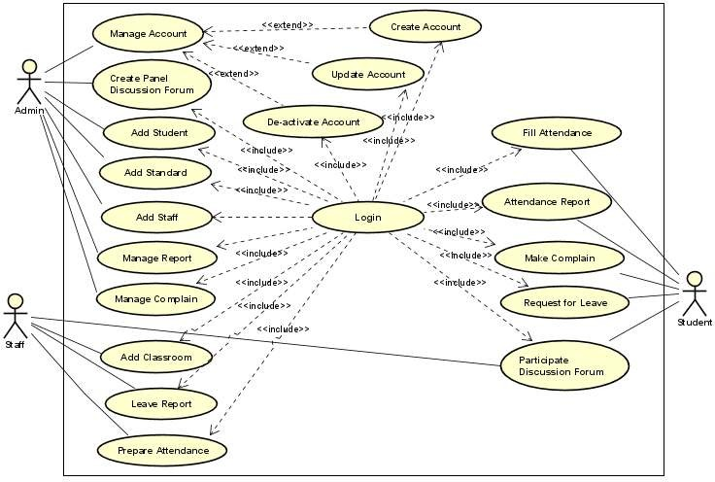
Figure 2-1 Use case Diagram

Use case Identification
Each Use Case describes the functionality to be built in the proposed system, which can include another Use Case’s functionality or extend another Use Case with its own behavior. The most important and basic use cases of this system are the following:
Table 2-2 Use case Identification
ID | Use Case Name
UC01 | Login
UC02 | Create Admin Account
UC03 | Manage Account
UC04 | Add Student
UC05 | Add Standard
UC06 | Add Classroom
UC07 | Add Staff
UC08 | Manage Complain
UC09 | Report Leave
UC10 | Create Panel Discussion Forum
UC11 | Participate Discussion Forum
UC12 | Fill Attendance
UC13 | Manage Report
UC14 | Attendance Report
UC15 | Make Complain
UC16 | Request for Leave
UC 17 | Logout

Use Case Description
Table 2-3 Login Use case Description
Use Case ID: 01
Use Case Name: Login
Actor: User (Admin, Student and Staff)
User: Wants to login to the system
Brief Description:
This use case describes how the user (Admin /Course and Lecturer) will login to the system in order to make use of order functions of the system
Input: Valid UserID and Password
Output: Has successfully Sign in
Pre-condition: User sign in using valid UserID and password
Post condition: The user can now make of the system function if is already registered user
Basic flow of Events:
- The system displays the homepage
- The user clicks on the login button
- The system displays the login page
- User key in username and password, and click login button
- The system verifies the provided details and, and then the system will display the particular user page
Exceptional Flows: E1 Key in wrong password and username
Alternate Flow: A1: Cancel
Constraints: Must key in a valid email address
Table 2-4 Manage User Use case Description
Use Case ID: 03
Use Case Name: Manage Account
Actor: Administrator
Administrator: Wants to add new user, delete user, edit user information
Brief Description:
This use case describes how the administrator login to the system to manage user
Input: Admin UserID and Password
Output: N/A
Pre-condition: Admin must log in to the system with valid UserID and Password
Post condition: The admin can now manage user
Basic flow of Events:
- The admin log into the system using its valid User ID and Password
- The system responds by verifying the Admin User ID and Password
- The admin page panel will now be displaying once the admin details has been verified by the system.
- The admin will then click on manage user button
- The system will then display the manage user page
- The administrator will then click on either edit user button, or delete user, or add new user button.
- The system will then display the particular page that the admin clicks on of
the functions
- The admin will then perform all the necessary process like add or edit user that he wants, and click the next button to finish.
- The system will then verify and save the new entries that been made by the
admin
- Thereafter, the system will now display new changes edited, added or deleted successfully
Exceptional Flows: E1 must have key in a wrong admin UserID and Password
Alternate Flow: A1: Cancel
Constraints: Must be an administrator
Table 2-5 Use case Description for Add Standard
Use Case Name: Add Standard
Primary Actor: Admin
Stakeholders and Interest:
Administrator: Wants to set ground rule
Brief Description:
This use case describes how administrator to the student must attend the class and what will happen if they miss the class
Input: User Login information
Output: Standard Notified
Pre-condition: Must be a Valid one
Post condition: Admin now can Manage student and staff based on the standard
Basic flow of Events:
- The admin goes to the homepage
- The admin then clicks on login button
- The system then displays admin login page
- The admin key in their valid Username and Password
- The system the responds by verifying the Username & Password key into the system
- The system then displays the Add Standard panel homepage
- The admin then uploads the standard
- The admin click upload button
- The system displays conformation message
- The admin returns back to homepage
Exceptional Flows: E1 Invalid Username or Password, Standard not settled successfully
Alternate Flow: A1 User can cancel the upload process
Constraints: Password must be valid as well as Username
Table 2-6 Use case description for Prepare Attendance
Use Case Name: Prepare Attendance
Primary Actor: Staff
Lecturer: Wants to prepare attendance for the student
Brief Description:
This use case describes how the Lecturer prepare attendance in the system.
Input: Lecturer UserID and Password
Output: attendance was prepared successfully
Pre-condition: The Lecturer must log in to the system
Post condition: Lecturer can now prepare the attendance
Basic flow of Events:
- The Lecturer log into the system using its valid User ID and Password
- The system responds by verifying the Lecturer User ID and Password
- The Lecturer page panel will now be displaying once the admin details has been verified by the system.
- The Lecturer will now click on prepare attendance button
- The system will then display prepare attendance page
- The Lecturer will now enter the necessary student information and then click submit button.
- The system will then verify the prepare attendance and save the prepared attendance information
- The system will now display attendance prepared successfully.
Exceptional Flows: E1 Must prepare
Alternate Flow: N/A
Constraints: Must be Lecturer of MTU web-based attendance management system
Table 2-7 Use case description for Fill Attendance
Use Case Name: Fill attendance
Primary Actor: Student
Stakeholders and Interest: Student: Wants to sign attendance
Brief Description:
This use case describes how the student will check their result after giving their test.
Input: Student UserID and Password
Output: N/A
Pre-condition: The student must log on to the system
Post condition: The student can now generate attendance report
Basic flow of Events:
- The student log into the system using their valid User ID and Password
- The system responds by verifying the student User ID and Password
- The main page will now be displaying once the student details has been verified by the system.
- The student will then click on fill attendance button
- The system will then display the fill attendance page.
- The student will fill attendance
- The system finally, display conformation message
Exceptional Flows: E1 Wrong UserID and Password
Alternate Flow: N/A
Constraints: Must be a registered student.
Table 2-8 Use case Description for Make Complain
Use Case Name: Make Complain
Primary Actor: Student
Stakeholders and Interest:
Student: Wants to make complain to admin and teacher
Brief Description:
This use case describes how the student will make any complain for concerning body.
Input: Student UserID and Password
Output: N/A
Pre-condition: The student must log on to the system
Post condition: The student can now generate the complaint submitted to admin/teacher
Basic flow of Events:
- The student log into the system using their valid User ID and Password
- The system responds by verifying the student User ID and Password
- The main page will now be displaying once the student details has been verified by the system.
- The student will then click on make complain button
- The system will then display the make complain page.
- The student will write any complain faced the student
- The system finally, display conformation message
Exceptional Flows: E1 Wrong UserID and Password
Alternate Flow: N/A
Constraints: Must be a registered student.

Sequence Diagram (SD)
The SD is used primarily to show the interactions between objects in the sequential order that those interactions occur. The main purpose of a sequence diagram is to define event sequences that result in some desired outcome. The focus is less on messages themselves and more on the order in which messages occur; nevertheless, most sequence diagrams will communicate what messages are sent between a system's objects as well as the order in which they occur. Sequence diagrams are used to model the logic of usage scenarios. Usage scenario is exactly which its name indicates-the description of a potential way our system is used. The logic of usage scenario developed here comprises the basic course of actions. The boxes across top of the diagram represent classifiers or their instances; typically use cases, objects, classes or actors.
The solid lines hanging from the boxes are called objects lifelines, representing the life span of object during the scenario being modeled. The long, thin boxes on the long-life lines are method invocation boxes indicating that the target object/class to fulfill a message is performing processing. Messages indicate as labeled arrows, when the source and the target of a message is an object or class label the signature of the method invoked in response to the message. However, if either the source or target is the human actor, then the message is labeled with brief text describing the information is available.

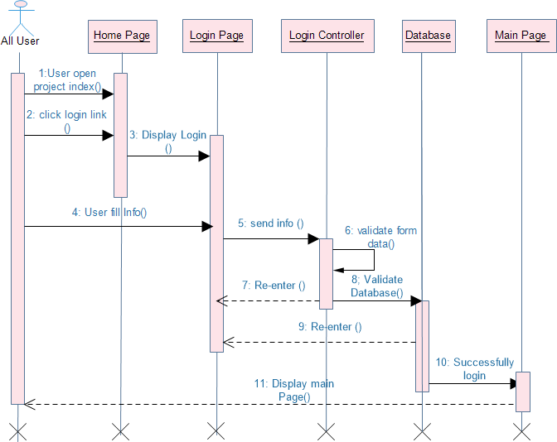

Figure 2-2 Sequence Diagram for Login
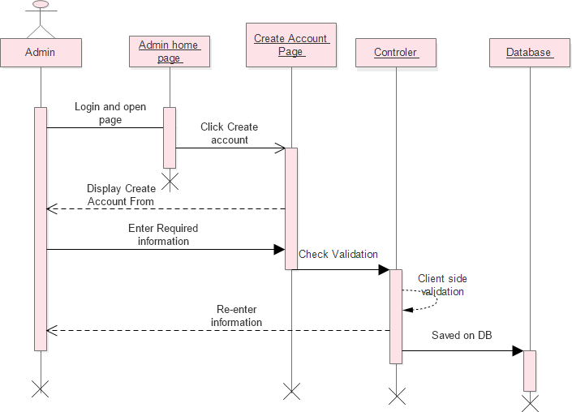
Figure 2-3 Sequence Diagram for Create Account
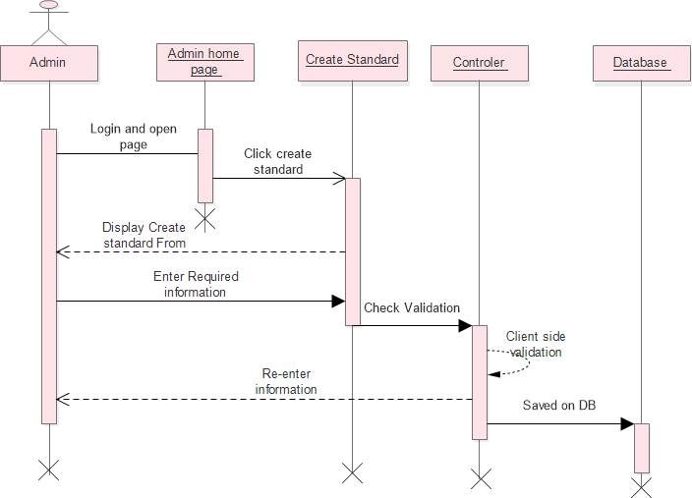
Figure 2-4 Sequence Diagram for create standard
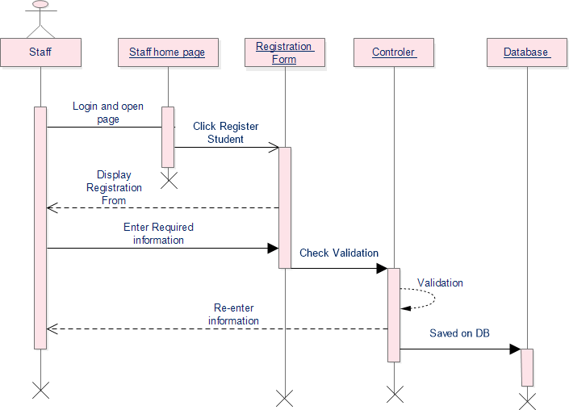
Figure 2-5 Sequence Diagram for Student Registration
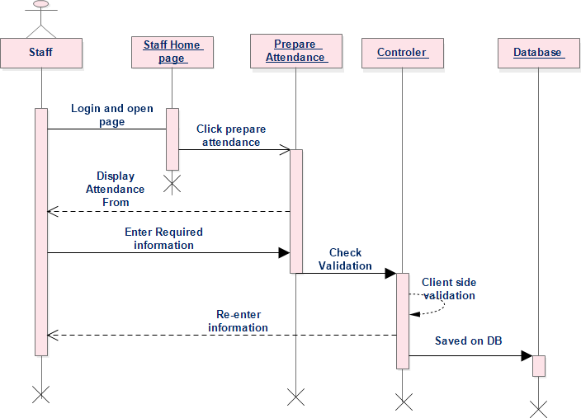
Figure 2-6 Sequence Diagram for Prepare Attendance

State Chart Diagram (SCD)
A SCD models the dynamic behavior of a single object (e.g., an Attendance record, a LeaveRequest, or a User Account) by showing the different states it can be in and the transitions between those states triggered by events. For example, an Attendance record might start as Not Marked, change to Marked Present or Marked Absent when the Staff fills attendance, then transition to Excused if a leave request is approved, and finally become Finalized after the attendance report is generated. Similarly, a LeaveRequest can move through states like Requested, Under Review, Approved, or Rejected. This diagram helps you understand how objects respond to events over time and ensures that all possible states are properly handled in your system design.
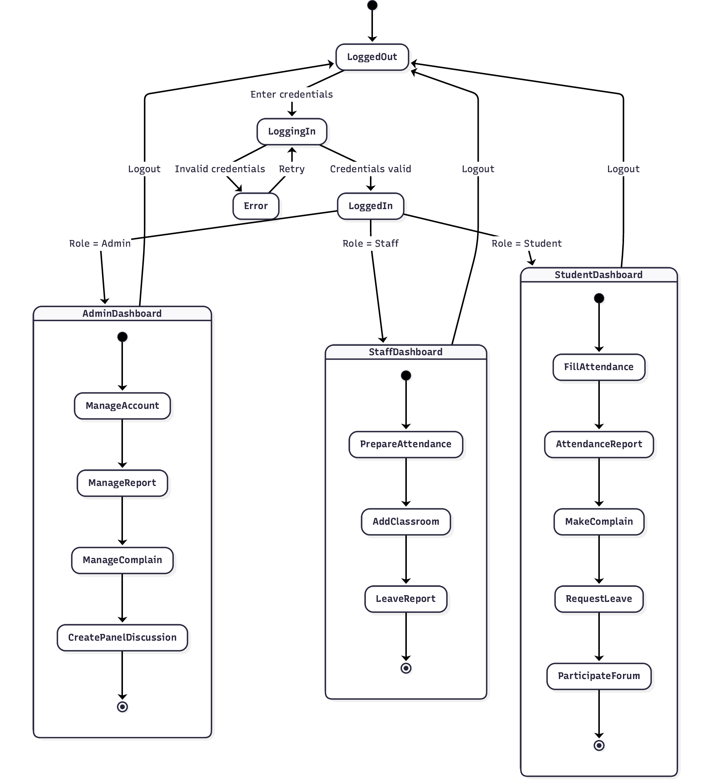
Figure 2-7 State Chart Diagram

Activity Diagram
An activity diagram describes the behavior of a system in terms of activities. Activities are modeling elements that represent the execution of a set of operations[5]. The execution of an activity can be triggered by the completion of other activities, by the availability of objects, or by external events. Activity diagrams are similar to flowchart diagrams in that they can be used to represent control flow (i.e., the order in which operations occur) and data flow (i.e., the objects that are exchanged among operations).
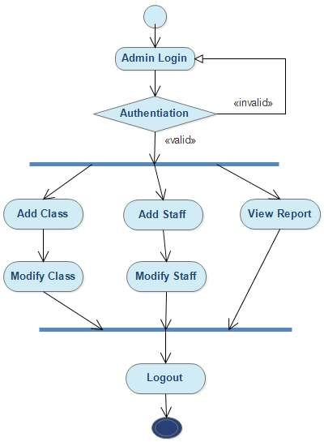
Figure 3-7 Admin side Activity Diagram

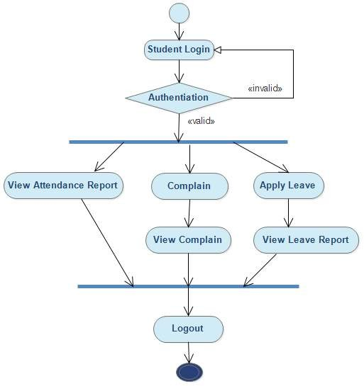
Figure 3-8 Student side Activity Diagram

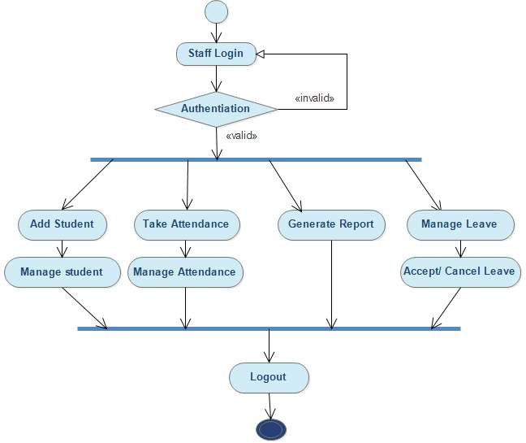
Figure 3-9 Staff side Activity Diagram

CRC (Class Responsibility Collaboration) Diagram
CRC is a brainstorming tool used in object-oriented design to identify and model classes in a system. Each CRC card represents a class, listing its responsibilities and its collaborators. This technique helps designers think through system behavior, ensure clear separation of concerns, and identify missing classes early in the development process. CRC is especially useful during the transition from use case analysis to detailed class design.
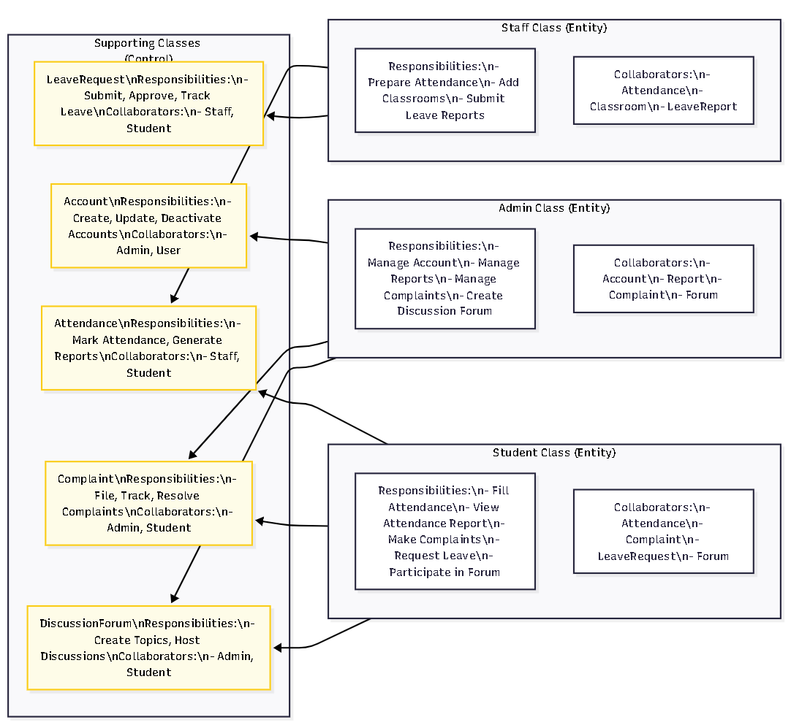
Table 2-9 CRC Diagram

Conceptual Modeling

Class Diagram
A Conceptual Class Diagram shows the main entities (classes), their attributes, and relationships without yet focusing on software details (like methods or visibility). Based on your use case actors and scenarios, here are the core conceptual classes:
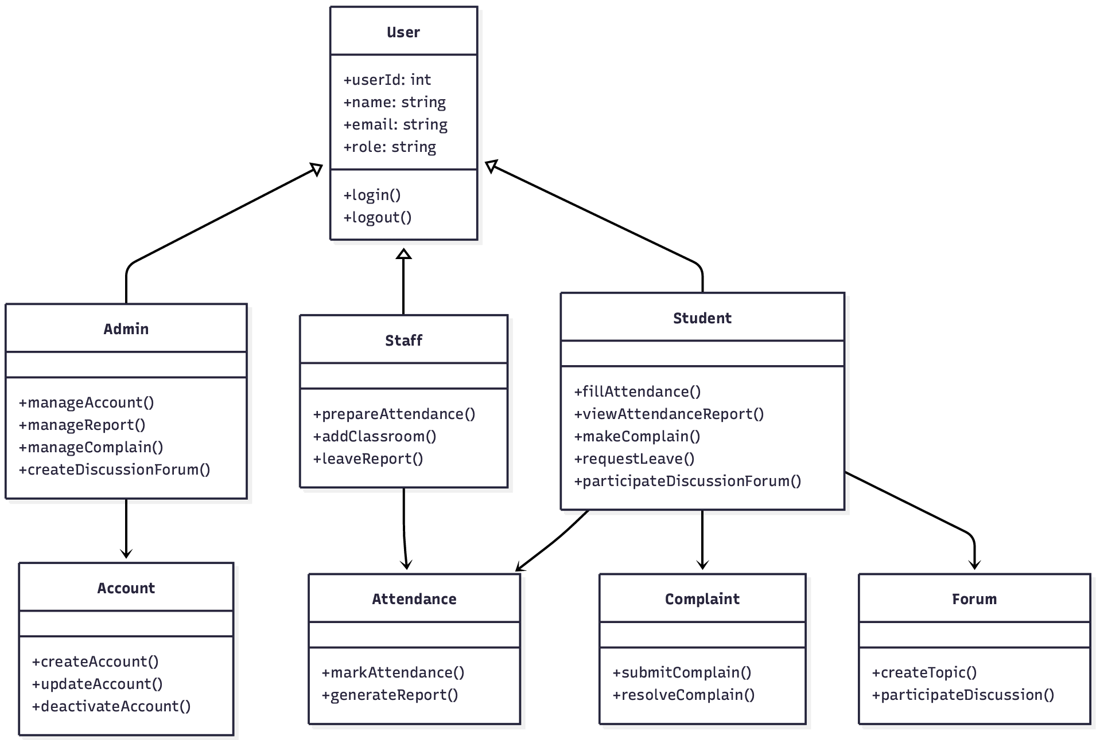
Figure 2-8 Class Diagram

Identifying Change Cases
Change Cases describe potential future changes to the system that are likely but not yet required. Identifying them helps make the design more robust and maintainable.
Change Cases for Online Attendance Management System:
Table 2-10 Change Case
Change Case ID | Description | Likelihood | Impact Area
CC-01 | Adding biometric (fingerprint) or facial recognition for attendance marking | Medium | Attendance class, Authentication
CC-02 | Integrating with university’s existing ERP or student information system | High | User, Student, Account classes
CC-03 | Supporting multiple attendance types (online, hybrid, in-person) | Medium | Attendance, Classroom
CC-04 | Adding QR code or NFC-based check-in/check-out | Medium | Attendance
CC-05 | Sending automated SMS/email alerts for low attendance or leave approval | High | NotificationService
CC-06 | Adding mobile app version (Android/iOS) | High | UI, API layer
CC-07 | Bulk import/export of attendance via Excel/CSV | Medium | Report class
CC-08 | Role for parent/guardian to view student attendance | Low | New Parent role
CC-09 | Automated attendance calculation based on timetable and holidays | Low | AttendanceRule class
CC-10 | Multi-language support (Afan Oromo, Amharic, English) | Medium | UI layer

User Interface Prototyping
User Interface Prototyping is the process of creating early, simplified versions of a system's user interface to visualize how users will interact with the software before full development begins. These prototypes can range from low-fidelity (hand-drawn sketches or wireframes) to high-fidelity (interactive, clickable mockups). The main purpose is to gather feedback from stakeholders (such as Admin, Staff, and Students at Bule Hora University) early in the design phase, identify usability issues, and refine the layout, navigation, and workflow without costly rework later. For the Online Attendance Management System, prototyping helps demonstrate screens like login, attendance marking, leave requests, complaint submission, and report viewing, ensuring the final system is intuitive and meets user expectations.
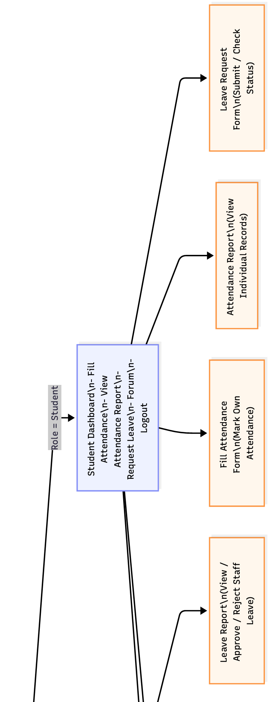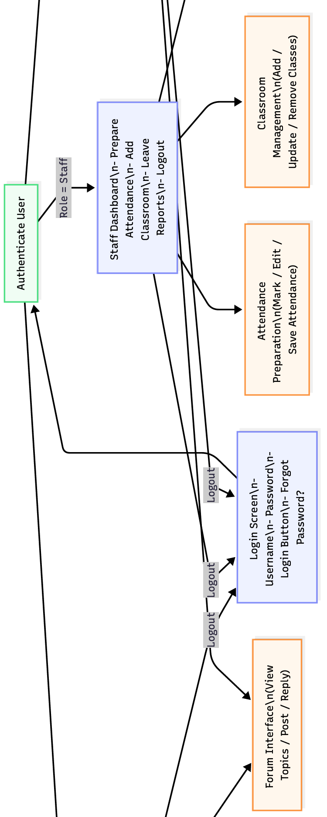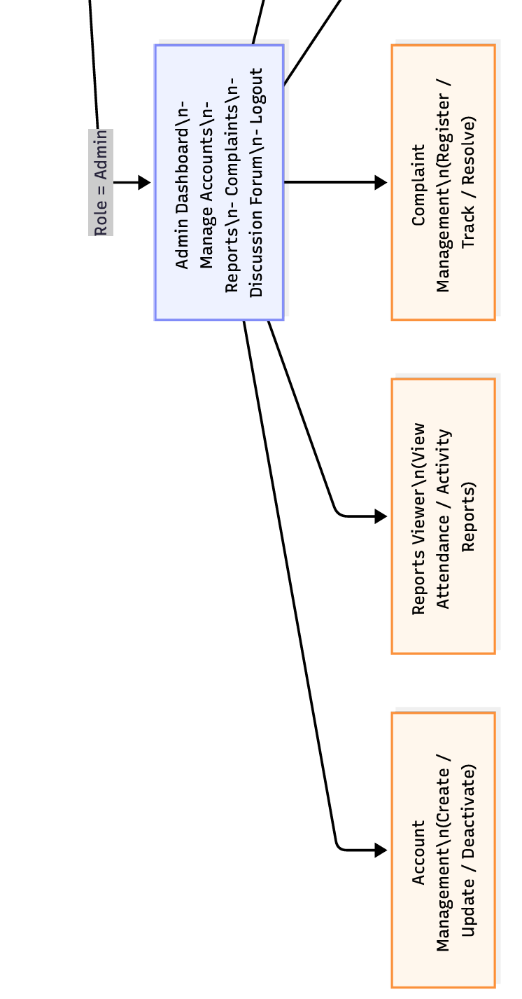
Figure 2-9 User Interface Prototyping

CHAPTER THREE

SYSTEM DESIGN

Introduction
System modeling is the process and focuses on decomposing the system into manageable parts. During requirements elicitation and analysis, we concentrated on the purpose and the functionality of the system. During system design, we focus on the processes, data structures, and software and hardware components necessary to implement it. The challenge of system design is that many conflicting criteria and constraints need to be met when decomposing the system.
The analysis model describes the system completely from the actor’s point of view and serves as the basis of communication between the client and the developers. The analysis model, however, does not contain information about the internal structure of the system, its hardware configuration, or, more generally, how the system should be realized. System design is the first step in this direction. System design results in the following products:
- List of design goals, describing the qualities of the system that developers should optimize.
- Software architecture, describing the subsystem decomposition in terms of subsystem responsibilities, dependencies among subsystems, subsystem mapping to hardware, and major policy decisions such as control flow, access control, and data storage.
And the purposes of object –oriented paradigm document is to provide an overview as to how to actually be used the proposed system and to obtain the information needed to derive the actual implementation of our system.
This project is designed in a manner that solves the problems of the organization by minimizing the work load that appears on the employees because of the existing manual system. It provides more efficient, reliable and time saving system. In this project design the team will try to show:
- How the project is designed
- What are tasks done under the whole project
- The different modules and their way of functioning are described here

Purpose and Goals of Design

Overview of System Design
An Online Attendance Management System for Bule Hora University is a web-based, three-tier client-server application that follows the Model-View-Controller architectural pattern, although a full MVC framework is optional for Version 1. The system is accessed via standard web browsers on desktop computers, laptops, tablets, and smartphones.
The purpose of the system design phase for the Bule Hora University Online Attendance Management System is to produce a detailed technical blueprint that guides developers during implementation. This blueprint translates the requirements and analysis models from Chapter Two into concrete architectural decisions, component specifications, database schemas, and interface definitions. The design phase ensures that the system will meet all functional requirements while satisfying critical quality attributes including performance, security, usability, maintainability, and scalability. Specifically, the design aims to convert the manual, paper-based clearance process into a fully digital, three-tier web application where students can initiate requests online, department heads can approve or reject with a single click, registrars can monitor progress and generate reports, and all actions are logged for audit purposes. The design must be sufficiently detailed that a competent developer can implement the system without needing to make significant architectural decisions, while also being flexible enough to accommodate future changes such as adding new departments or integrating with external systems.

Design Goal
The goal of system design according to the proposed project is to manage complexity by dividing the system into smaller, manageable pieces and to increase the system: -
- Efficiency: the system doing something well and thoroughly without waste of money and time.
- Flexibility: the system able to change to suite new condition or situation
- Security: the system should be secured, i.e., not allow unauthorized users to access the system.
- Reliability: the system should be reliable.
- Fault Tolerance: the system should be fault tolerant to loss of connectivity with the routing service
- Modifiability: the system should be modifiable to use different routing services.
There are a number of possible design criteria. These criteria are organized into four groups:
Performance criteria
Performance, dependability, and end user criteria are usually specified in the requirements or inferred from the application domain. The customer and the supplier (developer) dictate cost and maintenance criteria. It also includes: -
- Response time, the speed imposed on the system. The system should responsive maximum number of tasks with minimum times.
- Throughput, number of tasks accomplished in a fixed period of times.
- Memory, memory space available for speed optimizations should use efficiently.
Maintenance criteria
When we say the system is maintainable, we mean it can be maintained easily when changes arise from the user and designer/developers it is not only when changes arise but also when we consider the non-functional requirement.
Cost criteria
When we talk about cost, we mean the cost required for maintenance, installation and develop the system and to make the net worked computer to use the system effectively.
End user criteria
This is to mean the users of the system after the completion of the system, how the system is used in friendly manner for both the experienced and inexperienced users using the user interface and this is clearly stated in the users‟ documentation.

System Architecture

Current Software Architecture
The current manual attendance system has no software architecture because it is a paper-based process. However, for completeness, the current "architecture" can be described as:
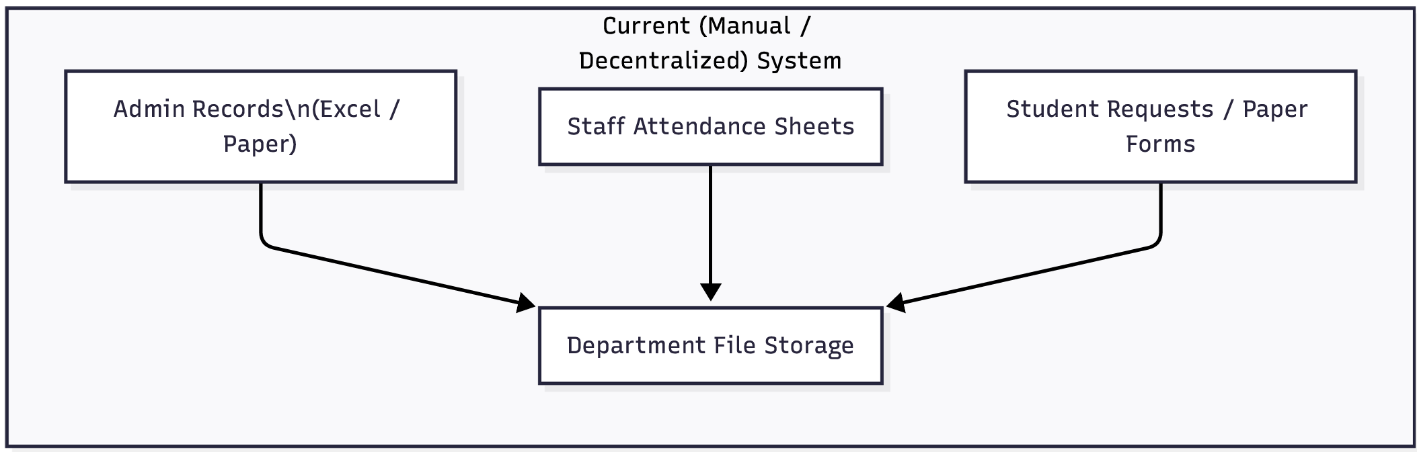
Figure 3-1 Current System Architecture

Proposed Software Architecture
The proposed system uses a three-tier architecture, sometimes referred to as a multi-tier architecture, that divides data persistence, business logic, and presentation into different layers. This division offers scalability, maintainability, and modularity.

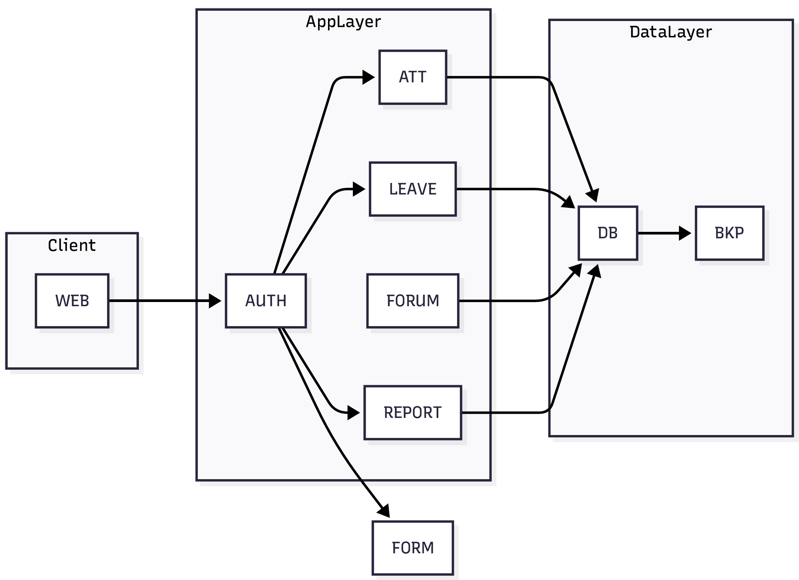
Figure 3-2 Proposed Software Architecture

System Decomposition
System decomposition is the process of disassembling a complicated system into smaller, easier-to-manage parts and subsystems. Every subsystem has a distinct function and uses well-defined interfaces to interact with other subsystems. Decomposition makes testing easier, allows for parallel development, and facilitates system expansion and maintenance.

Subsystem Decomposition
The system is divided into six major subsystems, each responsible for a distinct set of functionalities.
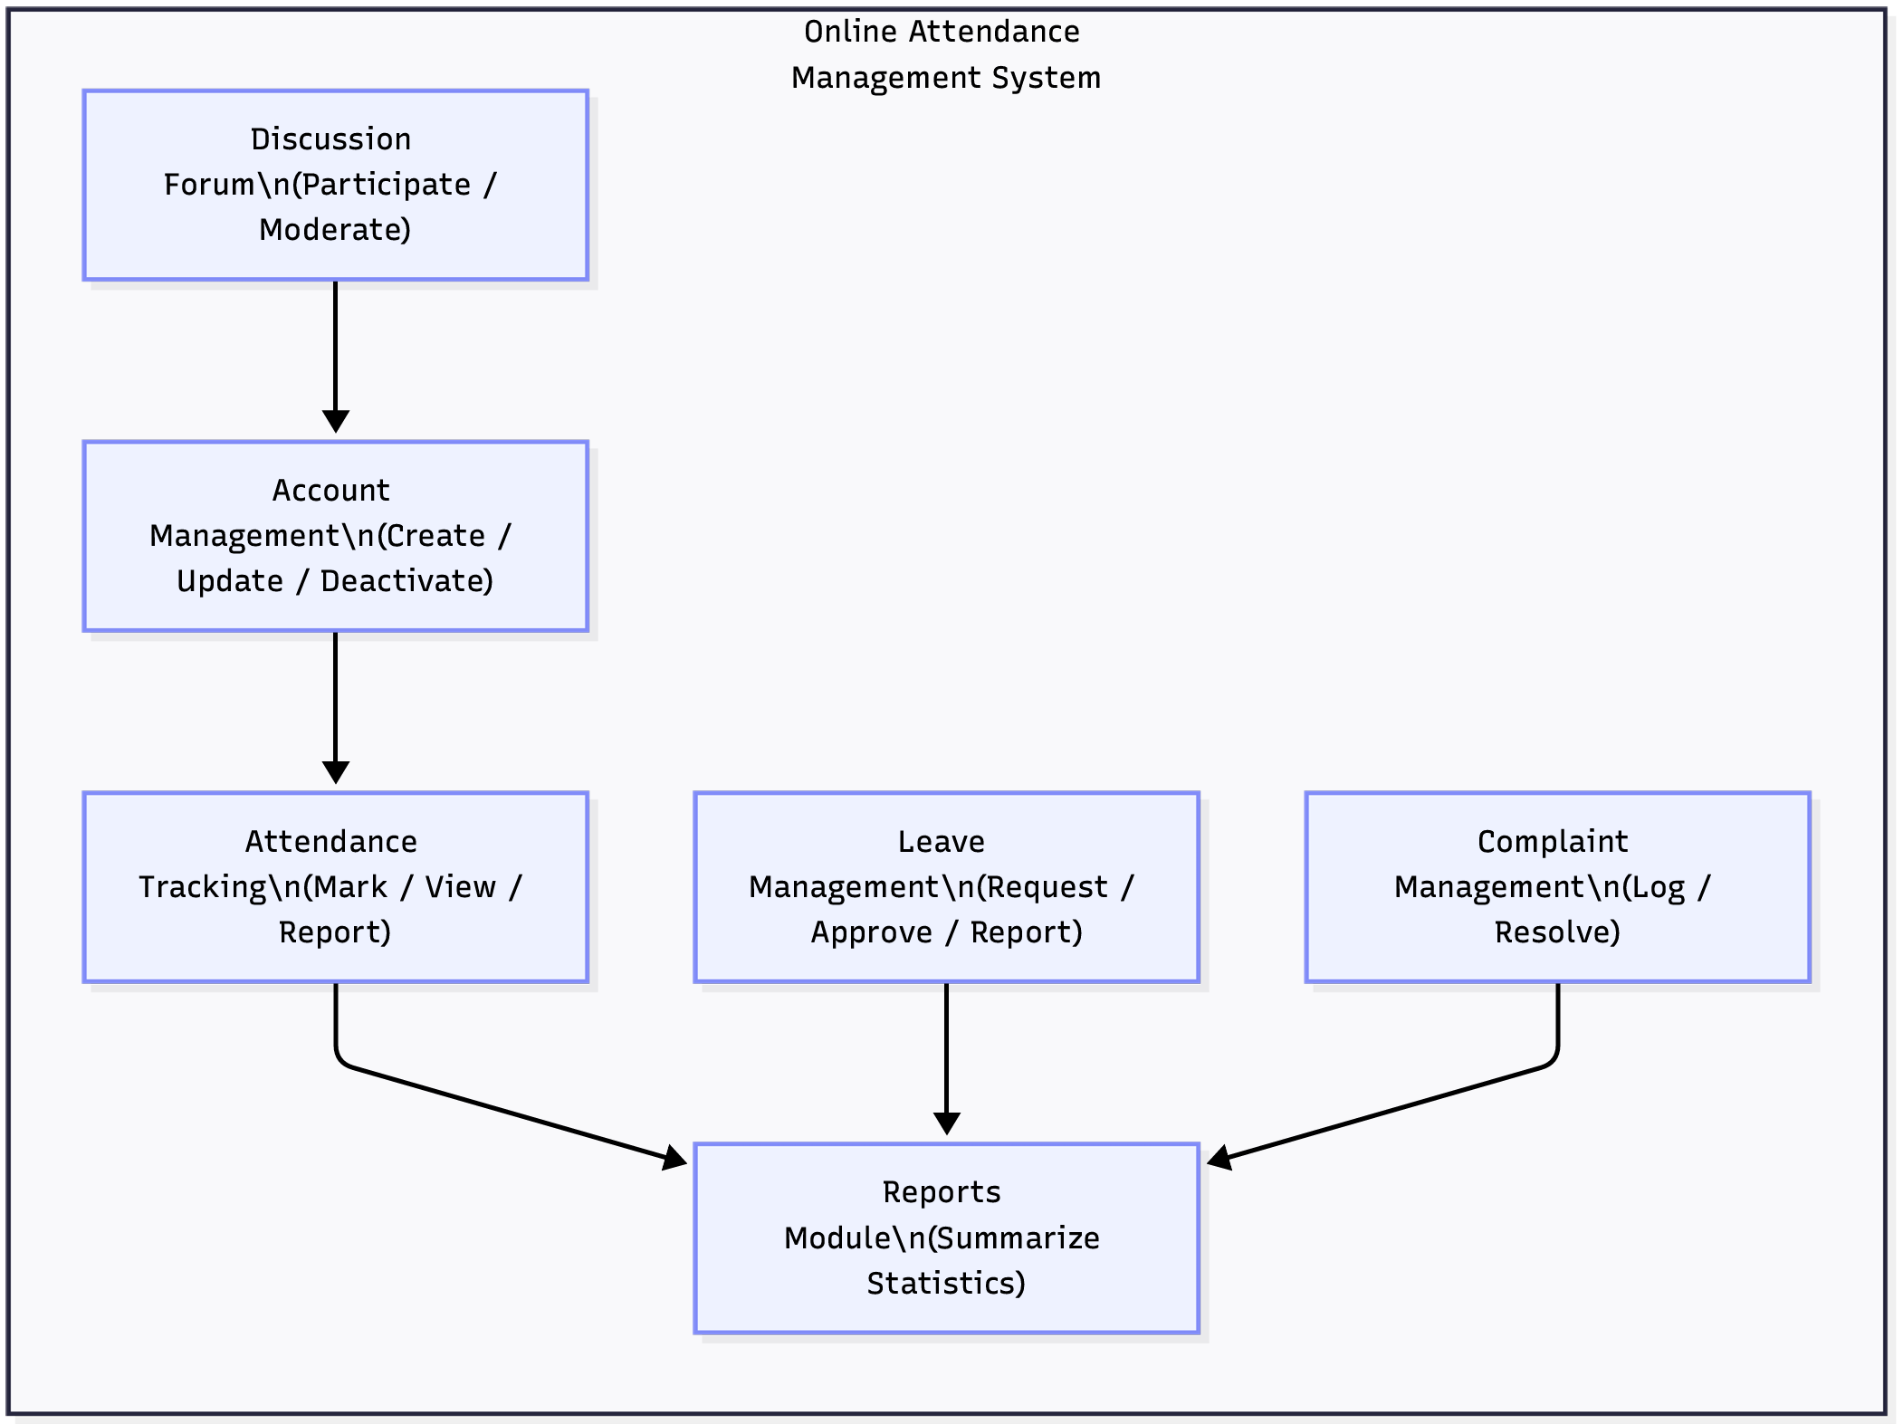
Figure 3-3 Subsystem Decomposition

Class Collaboration Diagram
A class collaboration diagram also called a communication diagram demonstrates how classes work together to do particular tasks. Collaboration diagrams highlight the structural links between objects and the messages they exchange, in contrast to sequence diagrams that focus on chronological ordering. For the BHU Online Attendance Management System, collaboration diagrams are presented for the three most critical use cases:
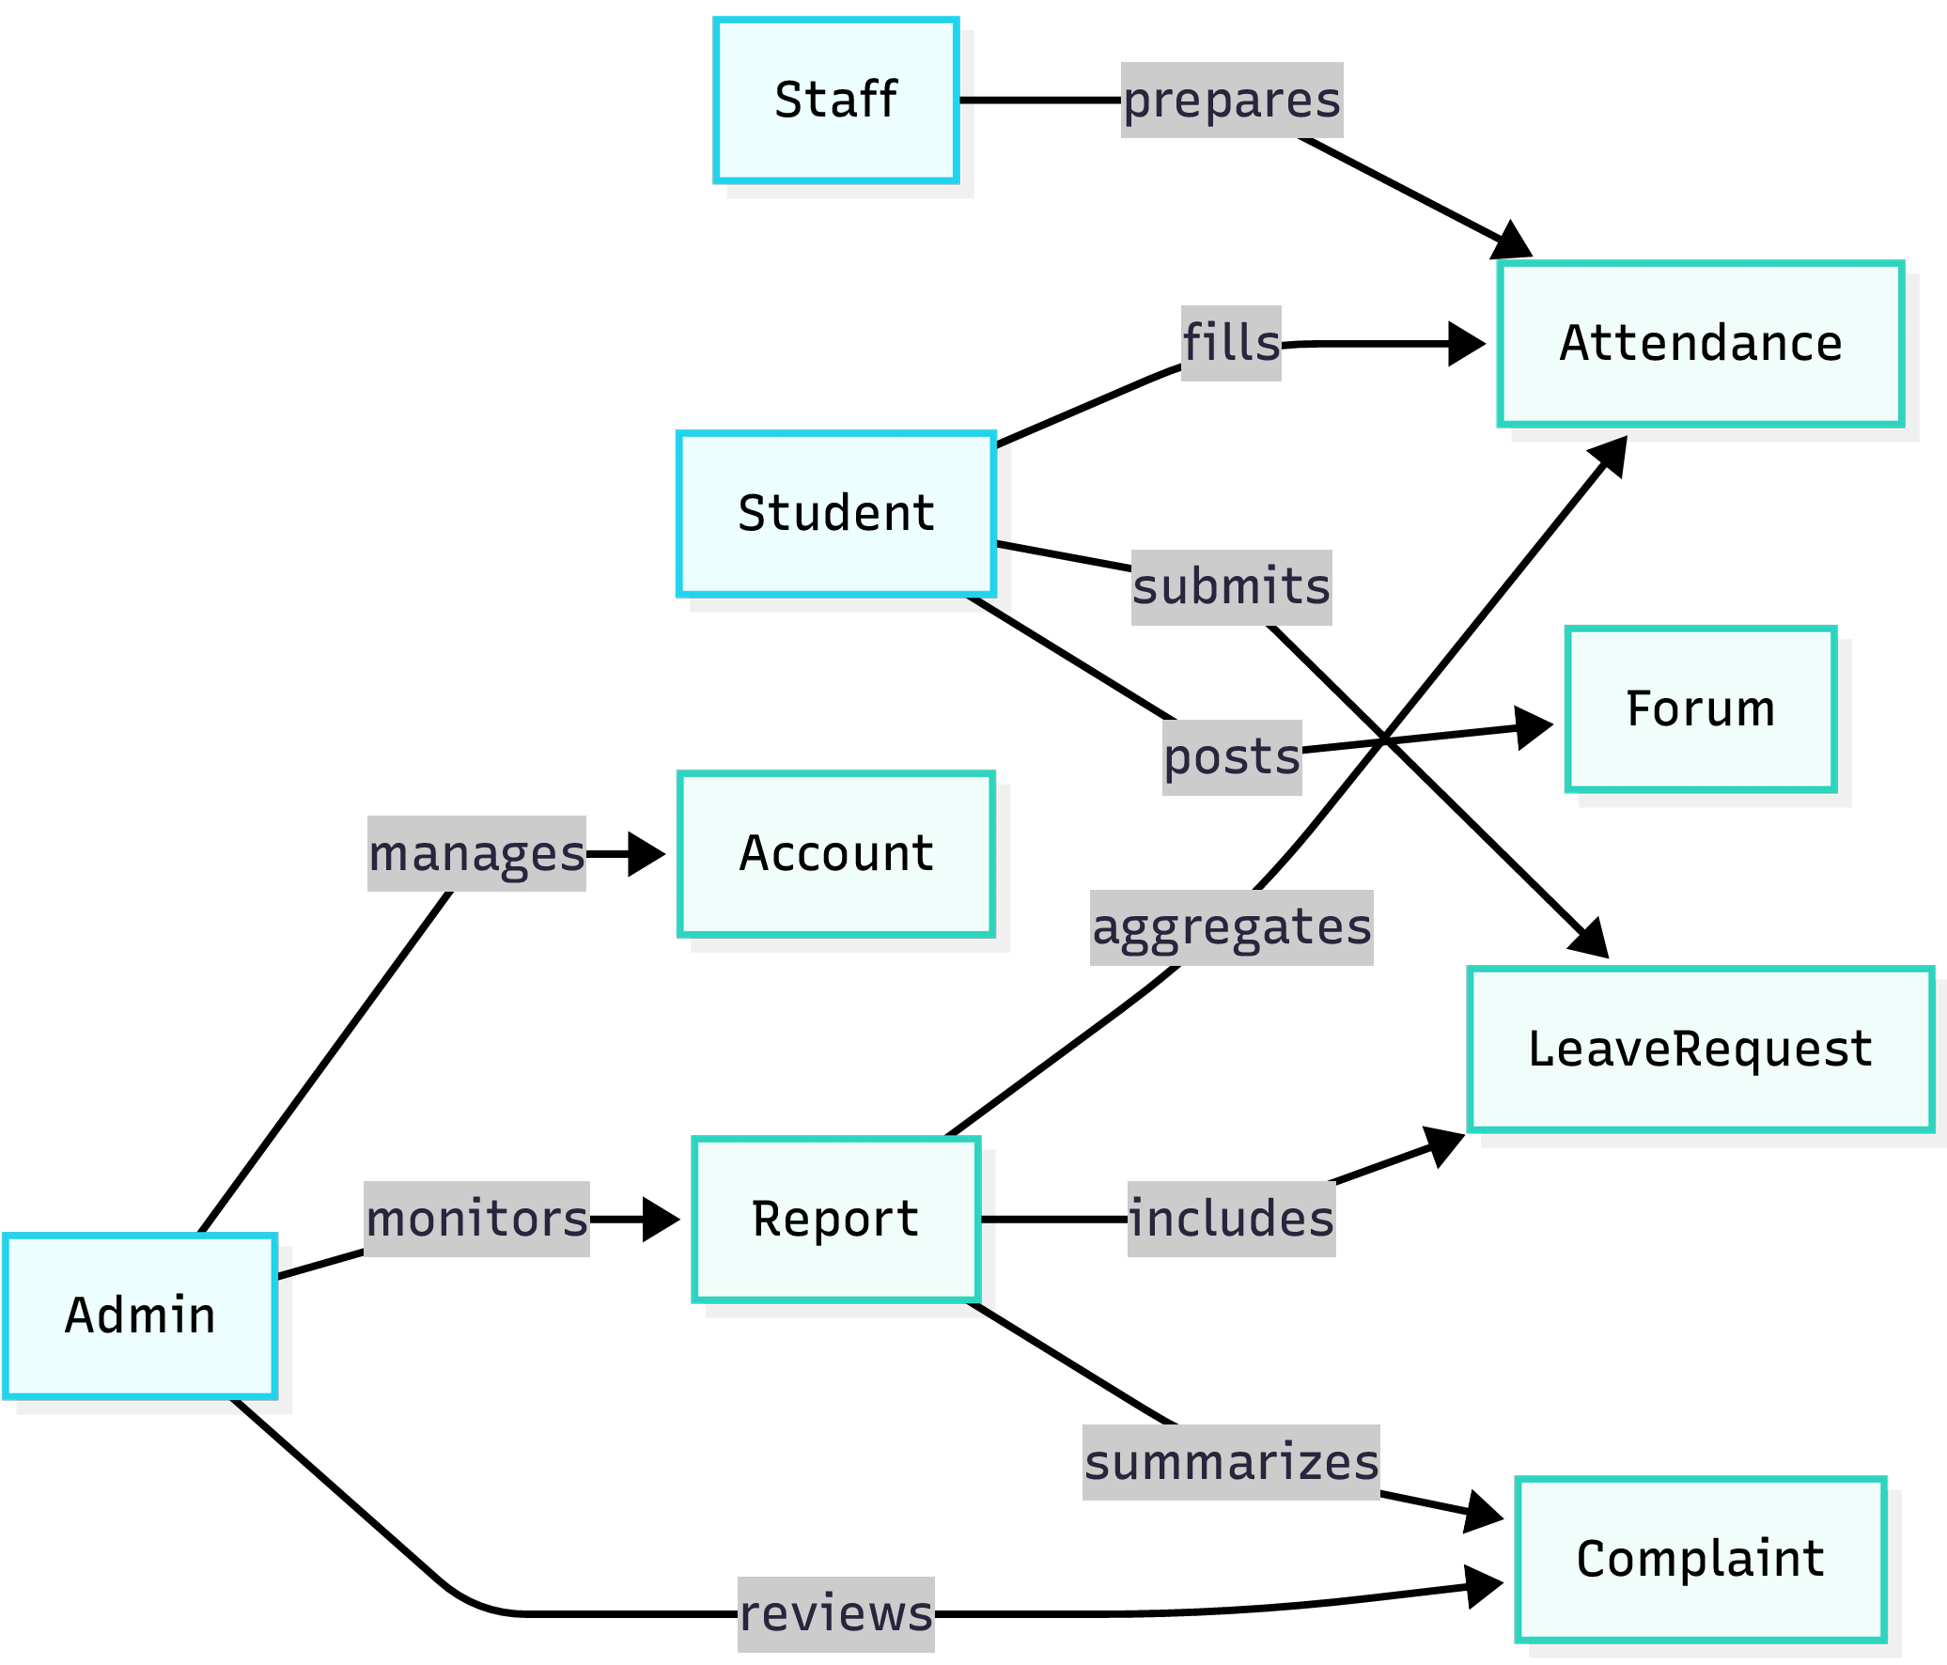
Figure 3-4 Class Collaboration Diagram

Layering Class Model
An architectural design known as layering divides classes into horizontal layers, each of which has a distinct function and can only communicate with layers that are next to it [7]. Layering increases maintainability, decreases coupling, and allows for the separation of issues. For the Bule Hora University Online Attendance Management System, a three-layer architecture is adopted.
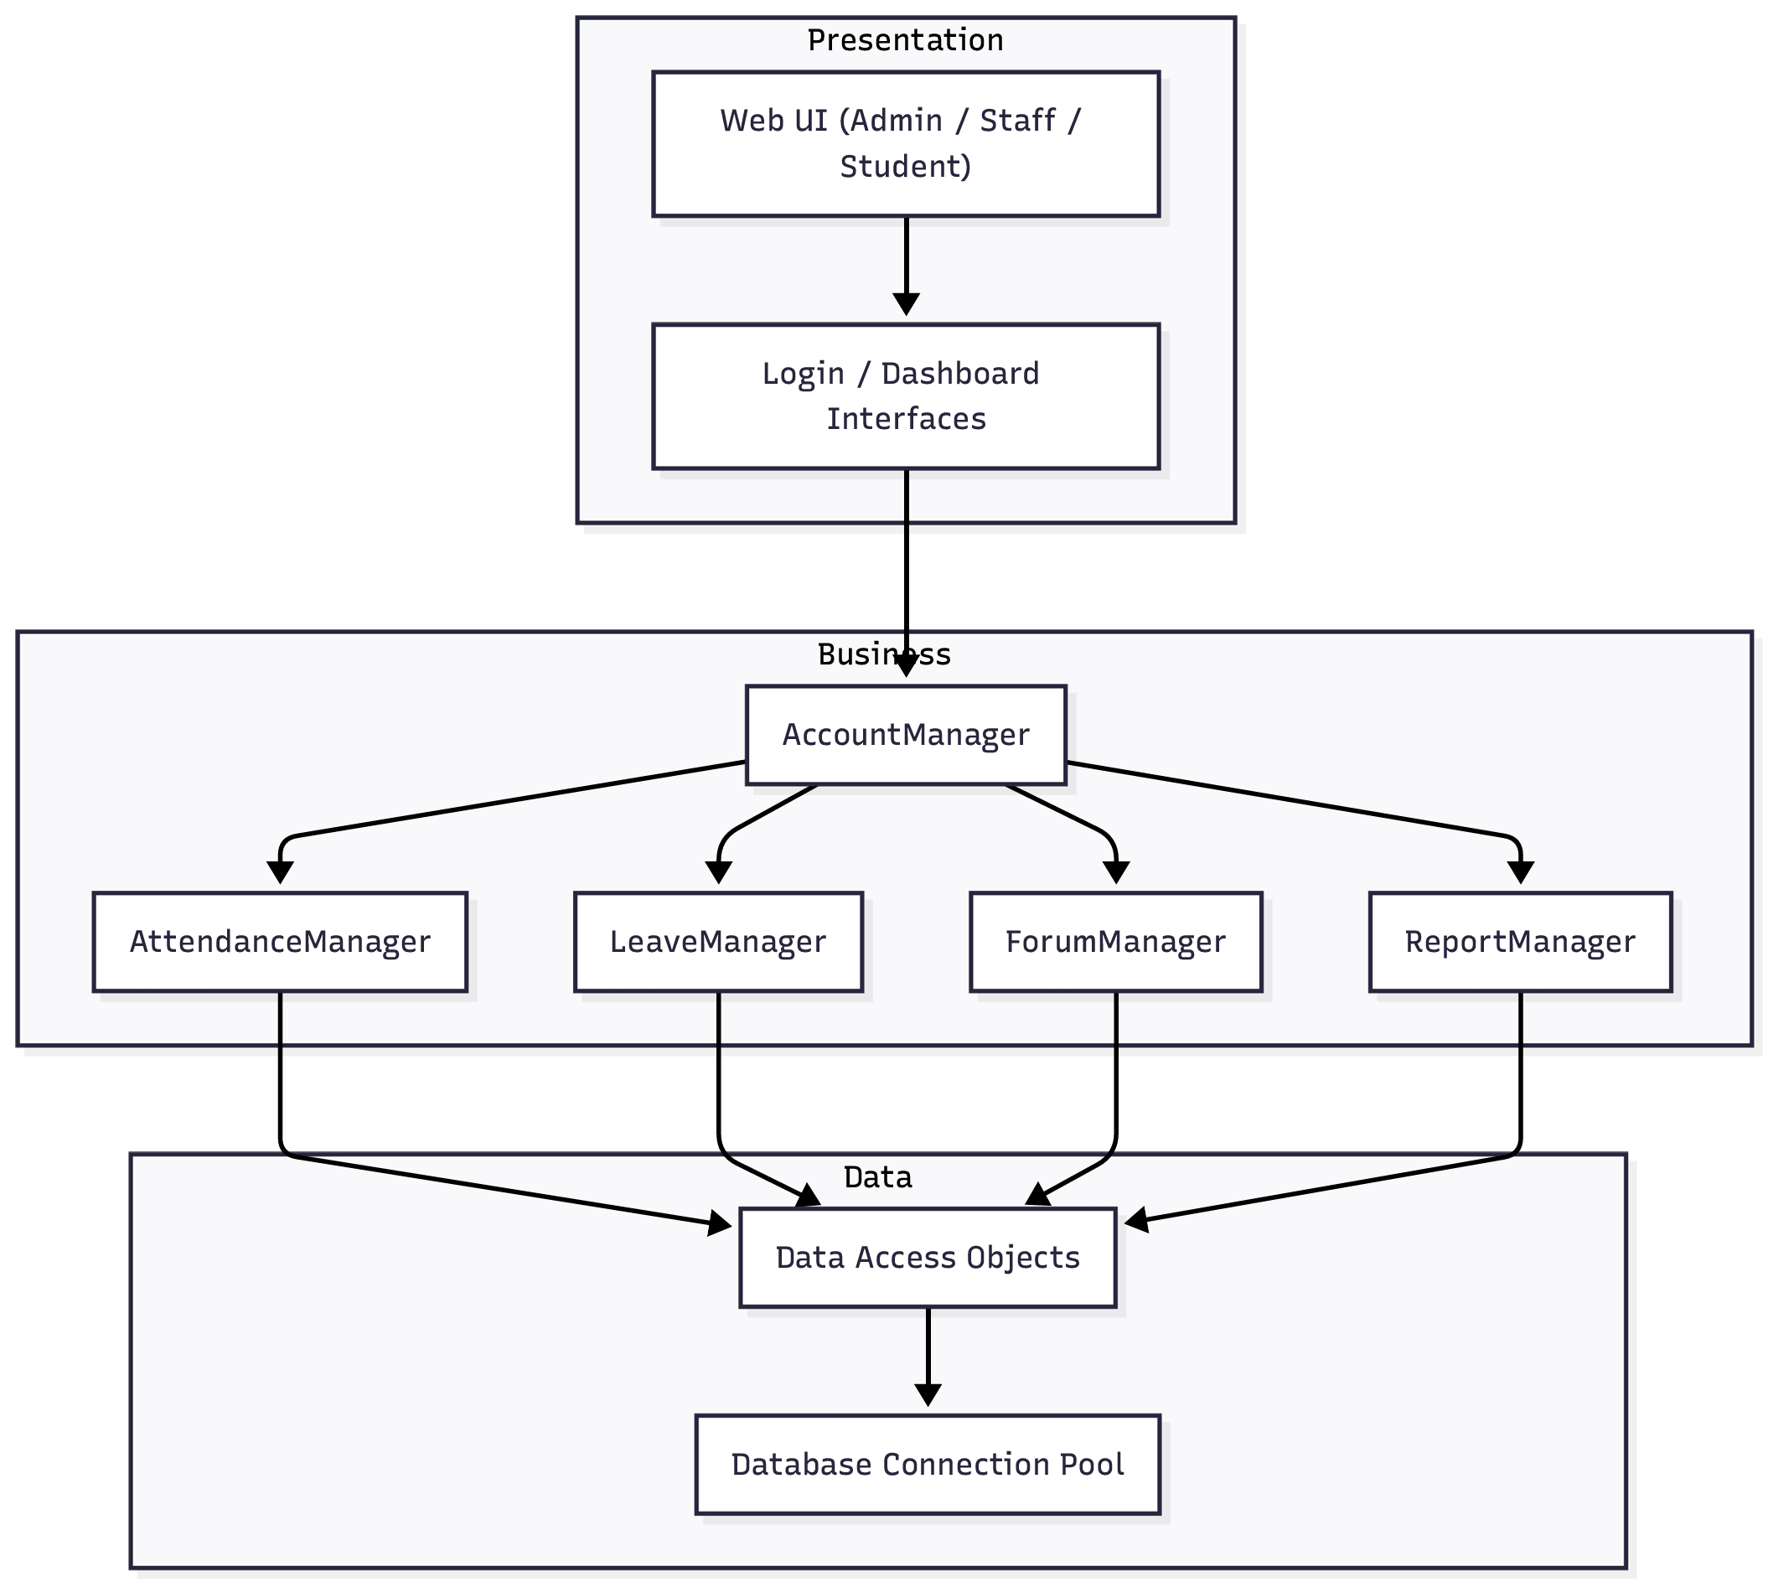
Figure 3-5Class Model Layer Diagram

Component Diagram
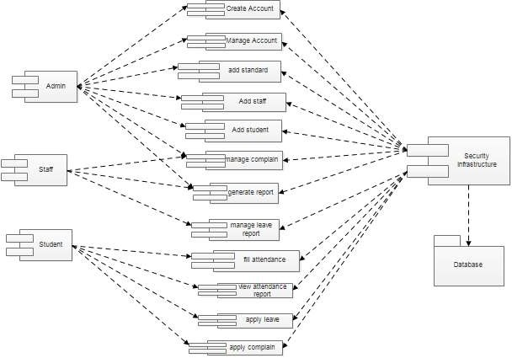
A component diagram breaks down the actual system under development into various high levels of functionality. Each component is responsible for one clear aim within the entire system and only interacts with other essential elements on a need-to-know basis. Component Diagrams illustrate the pieces of software, embedded controllers, etc. that will make up a system. A Component diagram has a higher level of abstraction than a Class diagram usually a component is implemented by one or more classes (or objects) at runtime. They are building blocks, such that eventually a component can encompass a large portion of a system. So, the basic components of online attendance management system are the following diagram:
Figure 3-6 Component Diagram

Deployment Diagram
A deployment diagram is a UML diagram type that shows the execution architecture of a system, including nodes such as hardware or software execution environments, and the middleware connecting them. Deployment diagrams are typically used to visualize the physical hardware and software of a system. Using it you can understand how the system will be physically deployed on the hardware. Deployment diagrams help model the hardware topology of a system compared to other UML diagram types which mostly outline the logical components of a system. Based on this the deployment diagram of student attendance management system is like the following:
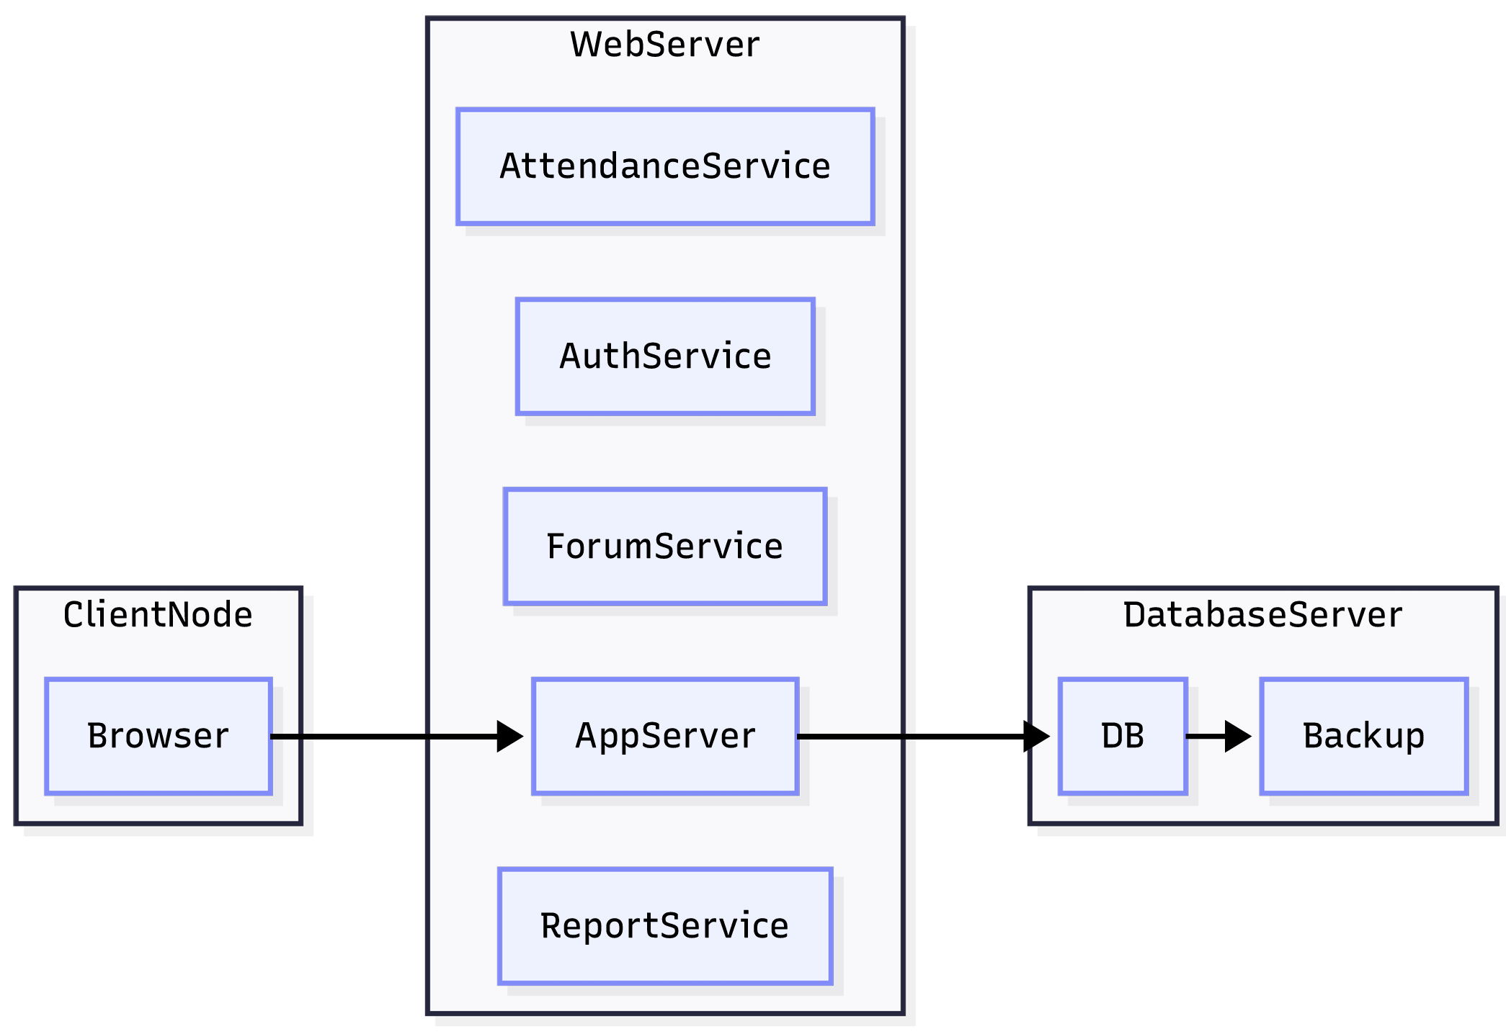
Figure 3-7 Deployment Diagram

Database Design (E-R diagram) for Relational Database
Database Design using an E-R Diagram for a Relational Database is about modeling your system’s data before creating tables. It helps you clearly define entities, attributes, and relationships, then convert them into relational tables [9].
The database design for the Online Attendance Management System for BHU follows the relational model and is implemented in MySQL 7.0.
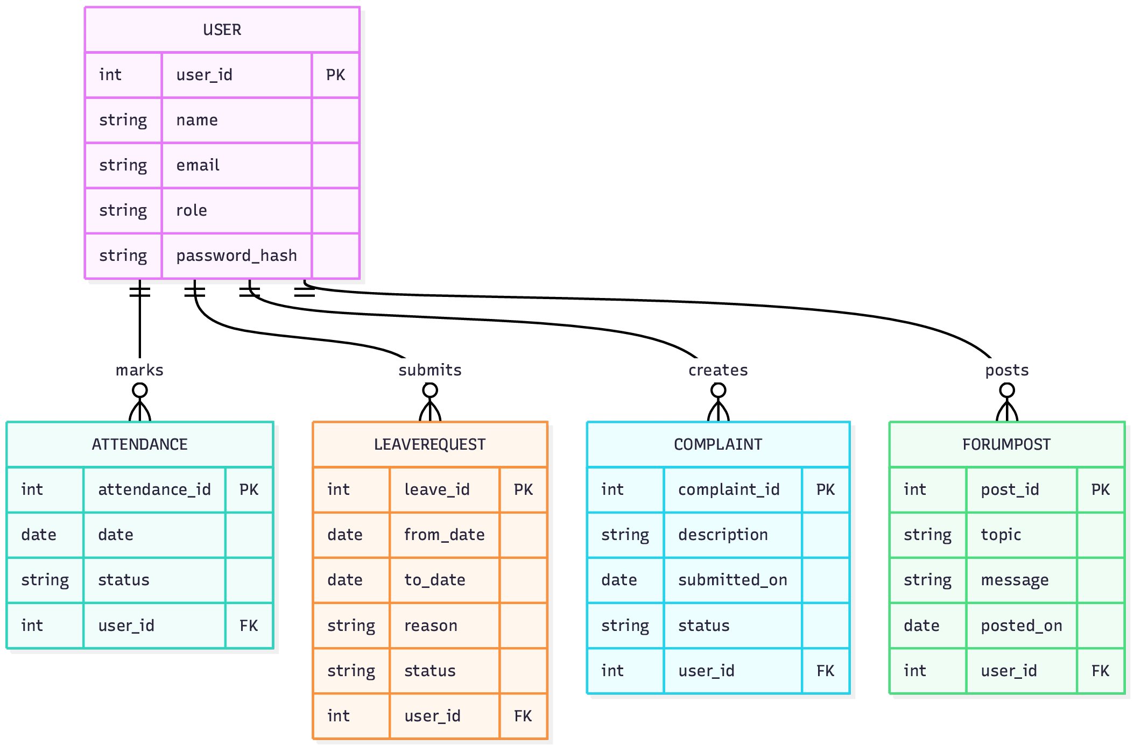
Figure 3-8 E-R Diagram

Persistence Modeling for Object Oriented Database
Persistence modeling explains the storage of objects in a persistent data store from the object-oriented domain model (Section 2.8). This part describes the ORM approach that bridges the gap between the object-oriented class diagram and the relational database schema, whereas part 3.9 provides a relational database design (tables, rows, foreign keys) that is the real implementation for this system.
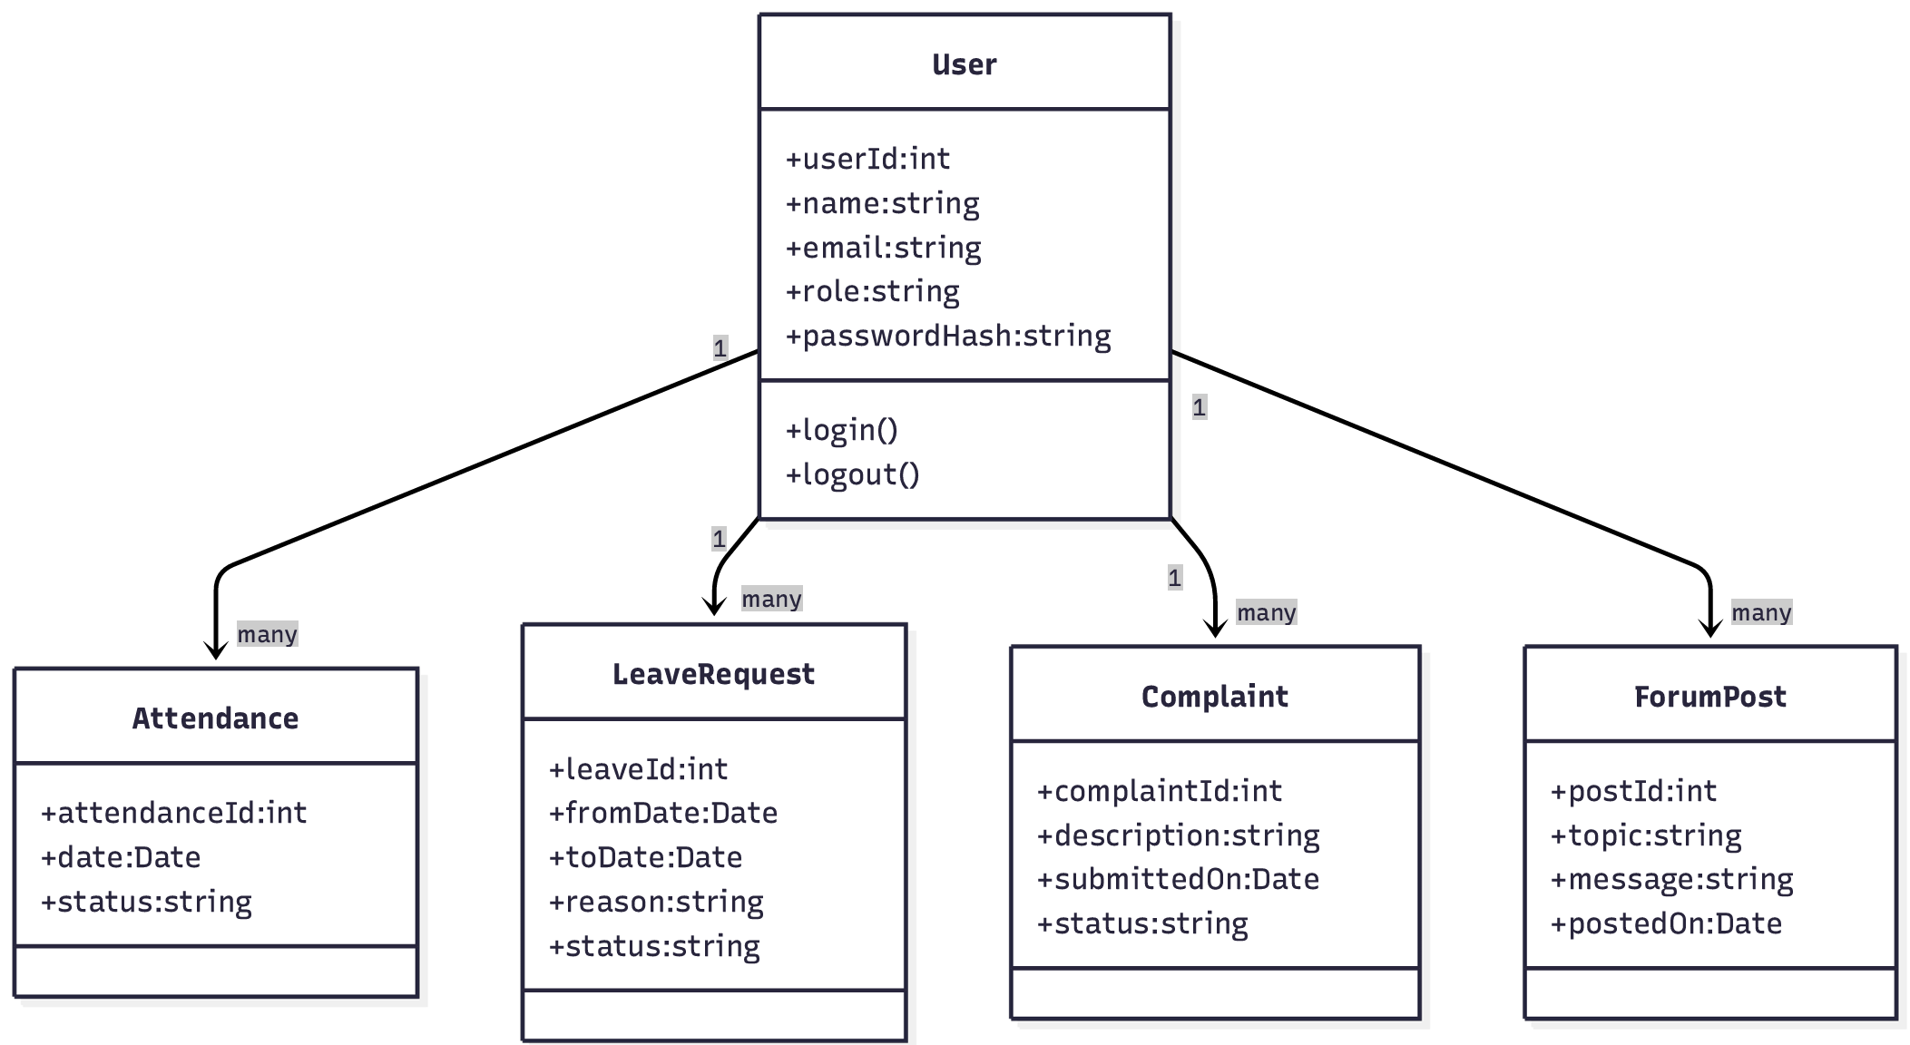
Figure 3-9 Persistence Model Diagram

Access Control and Security
Security is a critical concern for an Online Attendance Management System for BHU because it handles sensitive student data (personal information, financial status) and administrative actions that affect graduation eligibility[2]. The security architecture follows defense-in-depth principles, with multiple layers of protection.
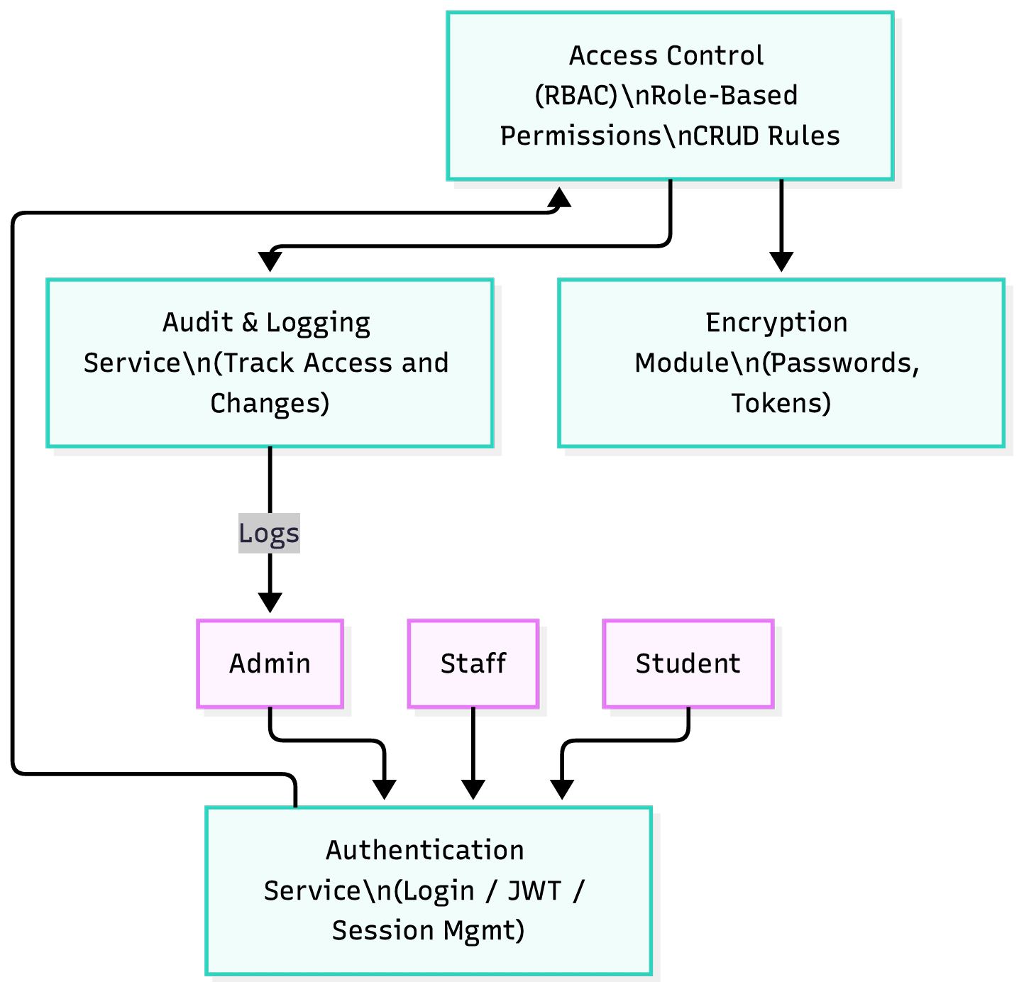
Figure 3-10 Access Control Diagram

User Interface Prototype Development
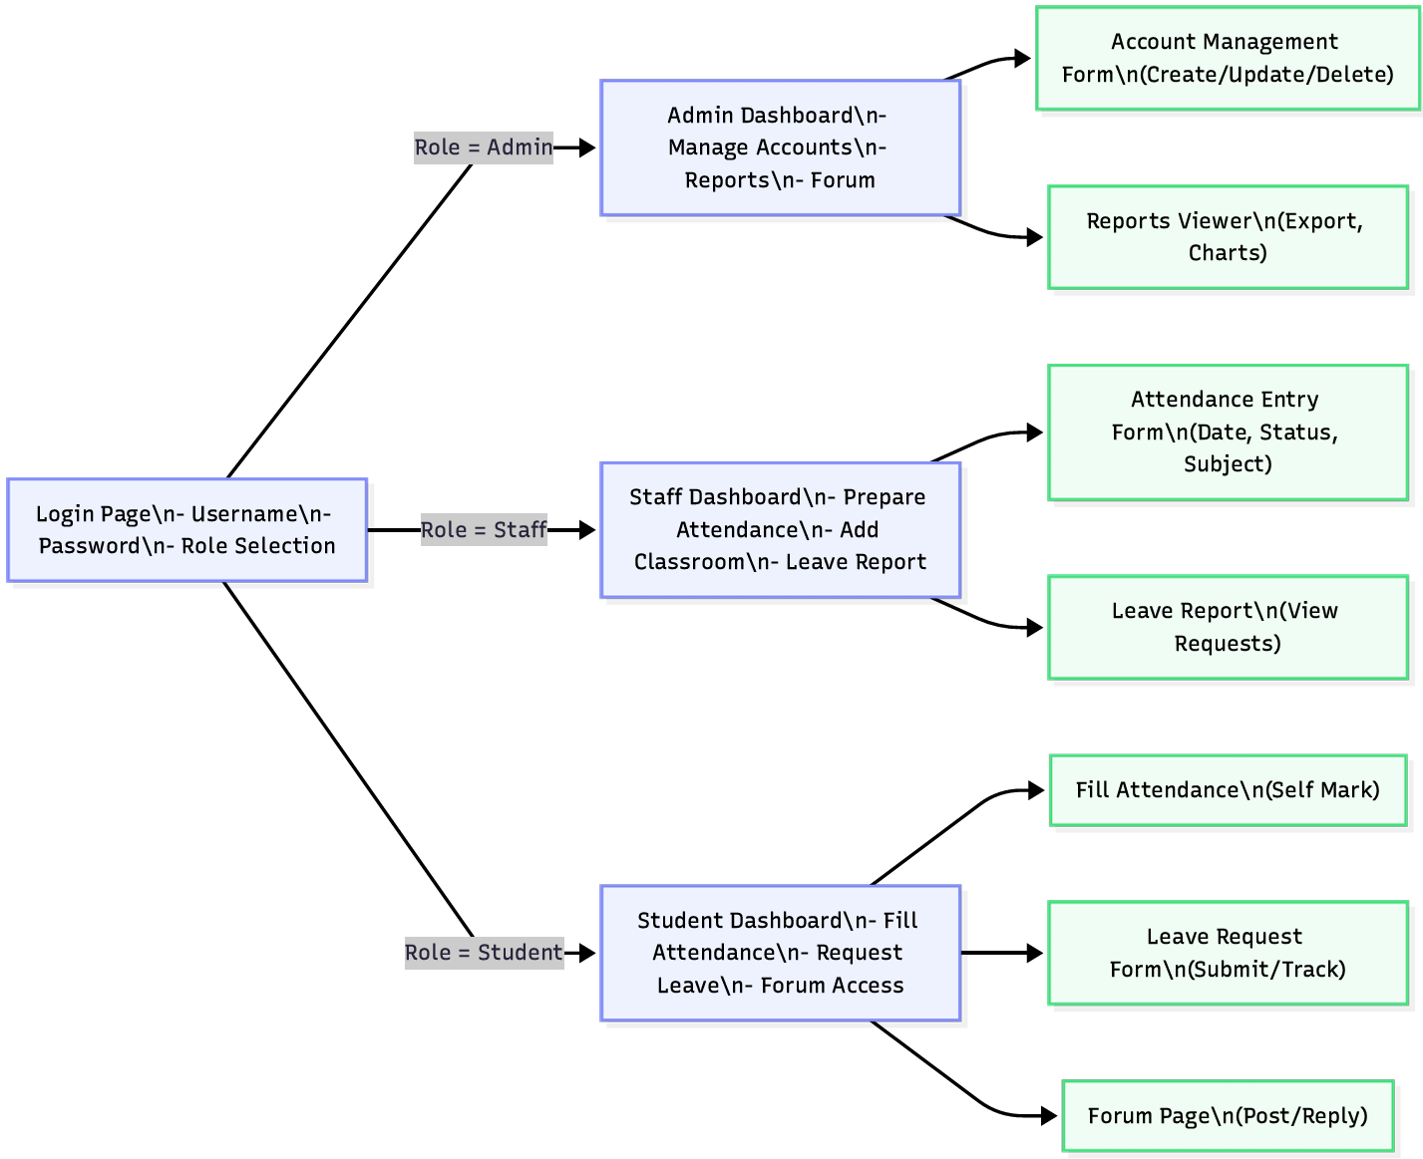
Figure 3-11 User Interface Prototype Diagram

References
- “(Approved by AICTE, Affiliated to Anna University and Accredited by NBA & NAAC with „A‟ Grade) MAY 2013,” vol. 003, no. May, 2013.
- S. Hassan, “Web-based Attendance Management System Submitted by Roll No : 08,” no. December 2015, 2018.
- P. Context, “Attendance management system project documentation”.
- “Attendance Management System”.
- Ambler, S. W. (2002). Agile Modeling: Effective Practices for Extreme Programming and the Unified Process. John Wiley & Sons.
- Ambler, S. W. (2002). Agile Modeling: Effective Practices for Extreme Programming and the Unified Process. John Wiley & Sons
- FPDF. (2024). FPDF - Free PDF Generator for PHP. http://www.fpdf.org/
- Federal Democratic Republic of Ethiopia. (2005). *Proclamation No. 514/2005: Freedom of the Mass Media and Access to Information Proclamation*. Federal Negarit Gazeta.
- MySQL Documentation Team. (2024). MySQL 8.0 Reference Manual. https://dev.mysql.com/doc/refman/8.0/en/

Appendix
Admin Dashboard
<?php
session_start();
include('../includes/db_connect.php');
include('../includes/auth.php');
// Check admin role
checkRole(['admin']);
// Get statistics
$stats = [];
// Total students
$result = $conn->query("SELECT COUNT(*) as total FROM students WHERE is_active = 1");
$stats['total_students'] = $result->fetch_assoc()['total'];
// Total teachers
$result = $conn->query("SELECT COUNT(*) as total FROM users WHERE role = 'teacher' AND is_active = 1");
$stats['total_teachers'] = $result->fetch_assoc()['total'];
// Total courses
$result = $conn->query("SELECT COUNT(*) as total FROM courses WHERE is_active = 1");
$stats['total_courses'] = $result->fetch_assoc()['total'];
// Today's attendance
$today = date('Y-m-d');
$result = $conn->query("SELECT COUNT(*) as total FROM attendance WHERE attendance_date = '$today'");
$stats['today_attendance'] = $result->fetch_assoc()['total'];
// Departments
$result = $conn->query("SELECT COUNT(*) as total FROM departments");
$stats['total_departments'] = $result->fetch_assoc()['total'];
// Recent activities
$activities = $conn->query("
SELECT 'New Student' as type, full_name, created_at
FROM students
WHERE DATE(created_at) = CURDATE()
UNION
SELECT 'Attendance Marked' as type, CONCAT('Course: ', c.course_name) as full_name, a.marked_at as created_at
FROM attendance a
JOIN courses c ON a.course_id = c.course_id
WHERE DATE(a.marked_at) = CURDATE()
LIMIT 10
");
?>
<!DOCTYPE html>
<html lang="en">
<head>
<meta charset="UTF-8">
<meta name="viewport" content="width=device-width, initial-scale=1.0">
<title>Admin Dashboard - DDU Attendance System</title>
<link href="https://cdn.jsdelivr.net/npm/bootstrap@5.3.0/dist/css/bootstrap.min.css" rel="stylesheet">
<link rel="stylesheet" href="https://cdnjs.cloudflare.com/ajax/libs/font-awesome/6.4.0/css/all.min.css">
<link rel="stylesheet" href="https://cdn.jsdelivr.net/npm/bootstrap-icons@1.11.0/font/bootstrap-icons.css"?>
<!-- Main Content -->
<div class="main-content">
<!-- Top Navbar -->
<div class="navbar-top d-flex justify-content-between align-items-center">
<div>
<h4 class="mb-0" style="color: var(--ddu-blue);">
<i class="fas fa-tachometer-alt"></i> Admin Dashboard
</h4>
<small class="text-muted">Welcome back, <?= htmlspecialchars($_SESSION['full_name']) ?></small>
<div class="dropdown">
<a href="#" class="d-flex align-items-center text-decoration-none" data-bs-toggle="dropdown">
<img src="<?= !empty($_SESSION['profile_image']) ? '../uploads/profiles/' . $_SESSION['profile_image'] : 'https://ui-avatars.com/api/?name=' . urlencode($_SESSION['full_name']) . '&background=003366&color=fff' ?>"
class="rounded-circle" width="40" height="40">
<div class="ms-2 d-none d-md-block">
<div class="fw-bold"><?= htmlspecialchars($_SESSION['full_name']) ?></div>
<small class="text-muted">Admin</small>
</div>
</a>
<div class="dropdown-menu dropdown-menu-end">
<a class="dropdown-item" href="profile.php">
<i class="fas fa-user"></i> Profile
</a>
<a class="dropdown-item" href="settings.php">
<i class="fas fa-cog"></i> Settings
</a>
<div class="dropdown-divider"></div>
<a class="dropdown-item" href="../logout.php">
<i class="fas fa-sign-out-alt"></i> Logout
</a>
</div>
</div>
</div>
</div>
<!-- JavaScript Libraries -->
<script src="https://cdn.jsdelivr.net/npm/bootstrap@5.3.0/dist/js/bootstrap.bundle.min.js"></script>
<script src="https://cdn.jsdelivr.net/npm/chart.js"></script>
<script>
// Attendance Chart
const ctx1 = document.getElementById('attendanceChart').getContext('2d');
const attendanceChart = new Chart(ctx1, {
type: 'line',
data: {
labels: ['Mon', 'Tue', 'Wed', 'Thu', 'Fri', 'Sat', 'Sun'],
datasets: [{
label: 'Present',
data: [120, 115, 125, 130, 110, 90, 95],
borderColor: '#28a745',
backgroundColor: 'rgba(40, 167, 69, 0.1)',
tension: 0.4
}, {
label: 'Absent',
data: [15, 20, 10, 5, 25, 35, 30],
borderColor: '#dc3545',
backgroundColor: 'rgba(220, 53, 69, 0.1)',
tension: 0.4
}]
},
options: {
responsive: true,
plugins: {
legend: {
position: 'top',
}
}
}
});
// Department Chart
const ctx2 = document.getElementById('departmentChart').getContext('2d');
const departmentChart = new Chart(ctx2, {
type: 'doughnut',
data: {
labels: ['Computer Science', 'Software Eng', 'IT', 'Electrical', 'Business'],
datasets: [{
data: [300, 250, 200, 180, 220],
backgroundColor: [
'#003366',
'#0066cc',
'#4facfe',
'#667eea',
'#764ba2'
]
}]
},
options: {
responsive: true,
plugins: {
legend: {
position: 'right',
}
}
}
});
// Toggle sidebar on mobile
function toggleSidebar() {
document.querySelector('.sidebar').classList.toggle('active');
}
</script>
</body>
</html>

